FROM BYTES TO BUSHELS: MACHINE LEARNING INSIGHTS FOR RURAL EMPOWERMENT

PROBLEM STATEMENT

Title: "Forecasting Fiscal Frontiers: Bridging the Gap with Machine Learning in Rural Resource Management"
In the heart of rural development lies a labyrinth of financial intricacies, where precision in budget allocation can be the linchpin for sustainable growth. The mission at hand is to build a robust machine learning model that transcends the conventional boundaries of financial forecasting. With an unwavering focus on predicting both Total Expenditure and Approved Labour Budget, this project embarks on a transformative journey to redefine the landscape of budget optimization and resource planning in the realm of rural projects.

Navigating the Landscape: Unraveling the Rural Financial Tapestry
The project is a response to the challenges faced in rural areas, where the allocation of resources holds the key to uplifting livelihoods and fostering economic resilience. The objective is clear: construct a predictive model that harnesses the power of data to unveil patterns, trends, and interdependencies within the vast array of features encapsulated in the MGNREGA dataset.

Optimizing Budgets, Empowering Communities
At its core, the project seeks to transcend the limitations of traditional budgeting approaches by leveraging the predictive capabilities of machine learning. The model aims to discern the nuanced relationships between various features, demographic factors, and project attributes to forecast both Total Expenditure and Approved Labour Budget accurately.

Strategic Impact: A Blueprint for Rural Prosperity
The implications of this project extend beyond the realms of data science. By predicting Total Expenditure and Approved Labour Budget, we lay the foundation for a strategic roadmap that not only optimizes financial resources but also empowers decision-makers with insights to drive effective resource planning for future projects. This, in turn, acts as a catalyst for fostering sustainable rural development, creating a ripple effect that transforms the lives of those residing in the heartlands of our nation.

A Symphony of Features: Orchestrating Data for Precision
In the pursuit of predictive excellence, the project meticulously examines a myriad of features—from the Total Number of JobCards issued to the intricate details of ongoing works. Each feature becomes a note in the symphony, contributing to the harmonious prediction of expenditures and labor budgets that resonate with the needs of the rural landscape.

Beyond Numbers: Human-Centric Development
This endeavor transcends mere numerical predictions; it is a testament to the fusion of data science with human-centric development. The model aspires not only to optimize budgets but also to enhance the quality of life for individuals in rural communities. It embodies a commitment to responsible and impactful resource allocation, underpinning a future where every investment contributes to the holistic well-being of the people it serves.
In conclusion, "Forecasting Fiscal Frontiers" represents more than a machine learning project—it symbolizes a commitment to reshaping the narrative of rural development. It is an ode to the possibilities that emerge when data science and social impact converge, envisioning a future where every byte of information contributes to the flourishing tapestry of rural prosperity.

DATASET DESCRIPTION
The dataset under consideration pertains to the Mahatma Gandhi National Rural Employment Guarantee Act (MGNREGA), a transformative initiative aimed at augmenting the livelihood security of households residing in rural areas across the nation. Enacted with the primary objective of assuring at least one hundred days of guaranteed wage employment in each financial year, this legislation targets households whose adult members willingly engage in unskilled manual labor. The overarching goal is to address socio-economic challenges prevalent in rural communities and foster sustainable development.This data was updated on 13/09/23.
MGNREGA, enacted to bolster the economic well-being of rural households, is rooted in the fundamental principle of providing gainful employment opportunities to those willing to participate in unskilled manual labor. The guarantee of a minimum of one hundred days of work in a financial year is a pivotal element of the program, ensuring a baseline level of income for participating households. This initiative not only uplifts the economic status of rural communities but also contributes to the overall development of the agricultural and rural sectors.
The dataset encompasses a comprehensive array of information pertaining to the implementation and outcomes of MGNREGA, providing valuable insights into the dynamics of rural employment generation and its impact on the targeted households. It serves as a reservoir of data, capturing nuances related to the allocation of work, wage disbursement, and the overall effectiveness of the program in meeting its socio-economic objectives.
Key facets of the dataset include details on the demographic composition of participating households, the geographical distribution of MGNREGA projects, and the economic implications for both individuals and communities involved. Through meticulous data collection and analysis, the dataset facilitates a nuanced understanding of the program's efficacy in enhancing livelihood security, reducing poverty, and fostering inclusive growth in rural areas.
In the context of our project, the MGNREGA dataset assumes paramount importance as a primary source of information. Leveraging this dataset, our analysis aims to unravel patterns, trends, and correlations that shed light on the multifaceted impact of MGNREGA on rural livelihoods. By delving into the intricacies of the dataset, we endeavor to contribute to the ongoing discourse on rural development and policy formulation.
In conclusion, the MGNREGA dataset serves as a cornerstone in our project, offering a rich repository of information to explore the intricacies of rural employment dynamics and the transformative potential of policy interventions. Through a systematic examination of this dataset, our project endeavors to make meaningful contributions to the understanding and improvement of initiatives aimed at enhancing the livelihood security of rural households in our country.
Resource: https://data.gov.in/catalog/mahatma-gandhi-national-rural-employment-guarantee-act-mgnrega

OBJECTIVE OF THE PROJECT
Predictive Modeling for Expenditure and Budget Allocation:
#1. Calculate the total number of job cards issued.
#2. Calculate the total number of workers in the dataset.
#3. Calculate the total number of active job cards.
#4. Calculate the total number of active workers.
#5. Calculate the ratio of SC workers to active workers.
#6. Calculate the ratio of SC workers to active workers.
#8. Find the total number of works taken up (New + Spill Over).
#9. Find the number of ongoing work.
#10. Number of completed work.
#11.The total percentage of NRM (National Rural Mission) works.
#12. The total expenditure(public+individual).
#13.The total percentage of Category B works.
#14.The total percentage of expenditure on agriculture and agriculture allied works.
#15. The total wages in Lakhs.
#16.The total material and skilled wages in Lakhs.
#17.The total administrative expenditure in Lakhs.
#18. The total number of job cards issued per state.
#19 The total number of workers per state.
#20 The total number of active job cards per state.
#21 The total number of active workers per state.
#22 The ratio of SC workers to active workers per state.
#23. The ratio of ST workers to active workers per state.
#24.Sum of the approved labor budget per state.
#25.The total number of works taken up (New + Spill Over) per state.
#26. The number of ongoing works per state.
#27. The number of completed works per state.
#28.Calculate the percentage of NRM works per state.
#29.Calculate the total expenditure (public + individual) per state.
#30.Calculate the percentage of Category B works per state.
#35.Calculate the percentage of expenditure on agriculture and agriculture allied works per state.
#36.Calculate the total expenditure in Lakhs per state.
#35.Calculate the total wages in Lakhs per state.
#36.Calculate the total material and skilled wages in Lakhs per state.
#37.Calculate the total administrative expenditure in Lakhs per state.
#38 Total of approved labour Budget.

Queries that will require machine learning solutions.
1.Demand Prediction: You can use historical data on job demand in different regions to build predictive models. This can help in allocating resources more efficiently and planning for labor requirements in various areas.
- Predictive Modeling for Expenditure and Budget Allocation: To Build a model to predict the Total Expenditure and Approved Labour Budget based on various features. This could help in optimizing budget allocation and resource planning for future projects.

Importing important libraries
import pandas as pd
import matplotlib.pyplot as plt
import seaborn as sns
from sklearn.preprocessing import StandardScaler

Checking Directory location
import os
os.getcwd()
'C:\\Users\\Apoorva'

Importing data
data = pd.read_csv("NREGA.csv")
data.head()
SNo. state_name district_name \
0 1 ANDAMAN AND NICOBAR NICOBARS
1 2 ANDAMAN AND NICOBAR NORTH AND MIDDLE ANDAMAN
2 3 ANDAMAN AND NICOBAR SOUTH ANDAMAN
3 4 ANDHRA PRADESH SRIKAKULAM
4 5 ANDHRA PRADESH VIZIANAGARAM
Total No. of JobCards issued Total No. of Workers \
0 6173 9866
1 18521 29500
2 13726 17491
3 445787 743762
4 388651 694622
Total No. of Active Job Cards Total No. of Active Workers \
0 1007 2011
1 6477 11920
2 3420 5016
3 384349 680409
4 350587 648430
SC workers against active workers ST workers against active workers \
0 0 1678
1 0 0
2 0 0
3 62310 39751
4 76009 18149
Approved Labour Budget ... Total No. of Works Takenup (New+Spill Over) \
0 34000 ... 172
1 76000 ... 532
2 40000 ... 401
3 16700000 ... 65095
4 16800000 ... 62481
Number of Ongoing Works Number of Completed Works \
0 172 0
1 458 74
2 174 227
3 47441 17654
4 49931 12550
% of NRM Expenditure(Public + Individual) % of Category B Works \
0 95.68 5
1 43.53 41
2 14.10 44
3 77.36 58
4 84.58 58
% of Expenditure on Agriculture & Agriculture Allied Works \
0 4.32
1 29.34
2 16.50
3 14.91
4 5.32
Total Exp(Rs. in Lakhs.) Wages(Rs. In Lakhs) \
0 5.470080 5.47008
1 167.966502 162.73531
2 79.200820 75.12606
3 50704.068270 39336.94327
4 48338.747750 37409.92904
Material and skilled Wages(Rs. In Lakhs) \
0 0.000000
1 5.231192
2 1.374760
3 10037.246630
4 9966.570016
Total Adm Expenditure (Rs. in Lakhs.)
0 0.00000
1 0.00000
2 2.70000
3 1329.87838
4 962.24870
[5 rows x 31 columns]
data.info() # We got to know that there are 740 rows and 31 columns . There are no null values and data type is 22 integer
# values , 2 object values and 7 float values.
<class 'pandas.core.frame.DataFrame'>
RangeIndex: 740 entries, 0 to 739
Data columns (total 31 columns):
# Column Non-Null Count Dtype
--- ------ -------------- -----
0 SNo. 740 non-null int64
1 state_name 740 non-null object
2 district_name 740 non-null object
3 Total No. of JobCards issued 740 non-null int64
4 Total No. of Workers 740 non-null int64
5 Total No. of Active Job Cards 740 non-null int64
6 Total No. of Active Workers 740 non-null int64
7 SC workers against active workers 740 non-null int64
8 ST workers against active workers 740 non-null int64
9 Approved Labour Budget 740 non-null int64
10 Persondays of Central Liability so far 740 non-null int64
11 SC persondays 740 non-null int64
12 ST persondays 740 non-null int64
13 Women Persondays 740 non-null int64
14 Average days of employment provided per Household 740 non-null int64
15 Average Wage rate per day per person(Rs.) 740 non-null float64
16 Total No of HHs completed 100 Days of Wage Employment 740 non-null int64
17 Total Households Worked 740 non-null int64
18 Total Individuals Worked 740 non-null int64
19 Differently abled persons worked 740 non-null int64
20 Number of GPs with NIL exp 740 non-null int64
21 Total No. of Works Takenup (New+Spill Over) 740 non-null int64
22 Number of Ongoing Works 740 non-null int64
23 Number of Completed Works 740 non-null int64
24 % of NRM Expenditure(Public + Individual) 740 non-null float64
25 % of Category B Works 740 non-null int64
26 % of Expenditure on Agriculture & Agriculture Allied Works 740 non-null float64
27 Total Exp(Rs. in Lakhs.) 740 non-null float64
28 Wages(Rs. In Lakhs) 740 non-null float64
29 Material and skilled Wages(Rs. In Lakhs) 740 non-null float64
30 Total Adm Expenditure (Rs. in Lakhs.) 740 non-null float64
dtypes: float64(7), int64(22), object(2)
memory usage: 179.3+ KB
data_new = data.drop(columns=["SNo."])
data_new.describe() #count - The number of not-empty values.
#mean - The average (mean) value.
#std - The standard deviation.
#min - the minimum value.
#25% - The 25% percentile*.
#50% - The 50% percentile*.
#75% - The 75% percentile*.
#max - the maximum value.
Total No. of JobCards issued Total No. of Workers \
count 7.400000e+02 7.400000e+02
mean 2.104687e+05 3.638288e+05
std 1.823353e+05 3.233418e+05
min 2.682000e+03 2.790000e+03
25% 8.367925e+04 1.418820e+05
50% 1.670905e+05 2.898630e+05
75% 2.837125e+05 4.951898e+05
max 1.404131e+06 2.362498e+06
Total No. of Active Job Cards Total No. of Active Workers \
count 740.000000 7.400000e+02
mean 131146.417568 2.371340e+05
std 114671.685185 2.154017e+05
min 1.000000 2.000000e+00
25% 48437.250000 8.864525e+04
50% 107381.500000 1.886295e+05
75% 177340.000000 3.205190e+05
max 971202.000000 1.728854e+06
SC workers against active workers ST workers against active workers \
count 740.000000 740.000000
mean 47464.445946 39057.983784
std 63258.346732 69065.846436
min 0.000000 0.000000
25% 7858.000000 1188.000000
50% 31010.500000 11741.500000
75% 63158.000000 48503.500000
max 587213.000000 674729.000000
Approved Labour Budget Persondays of Central Liability so far \
count 7.400000e+02 7.400000e+02
mean 2.982514e+06 2.233722e+06
std 2.793716e+06 2.564060e+06
min 0.000000e+00 0.000000e+00
25% 1.029378e+06 4.891815e+05
50% 2.276960e+06 1.511060e+06
75% 3.966140e+06 2.839730e+06
max 2.052607e+07 1.588081e+07
SC persondays ST persondays ... \
count 7.400000e+02 7.400000e+02 ...
mean 4.340572e+05 3.783246e+05 ...
std 6.333686e+05 9.388512e+05 ...
min 0.000000e+00 0.000000e+00 ...
25% 2.893650e+04 5.239500e+03 ...
50% 2.027620e+05 7.276150e+04 ...
75% 5.250492e+05 4.297868e+05 ...
max 3.974284e+06 1.234381e+07 ...
Total No. of Works Takenup (New+Spill Over) Number of Ongoing Works \
count 740.000000 740.000000
mean 22656.571622 17641.964865
std 21336.511869 17569.288520
min 3.000000 3.000000
25% 6975.250000 5329.000000
50% 17438.500000 13149.000000
75% 32545.000000 25556.500000
max 199175.000000 191889.000000
Number of Completed Works % of NRM Expenditure(Public + Individual) \
count 740.000000 740.000000
mean 5014.606757 26.412716
std 6304.127599 21.193368
min 0.000000 0.000000
25% 763.250000 8.850000
50% 2931.500000 21.700000
75% 6846.750000 41.580000
max 60770.000000 100.000000
% of Category B Works \
count 740.000000
mean 53.204054
std 26.552274
min 0.000000
25% 35.000000
50% 57.000000
75% 73.000000
max 98.000000
% of Expenditure on Agriculture & Agriculture Allied Works \
count 740.000000
mean 38.590176
std 21.308297
min 0.000000
25% 22.500000
50% 36.005000
75% 53.280000
max 100.000000
Total Exp(Rs. in Lakhs.) Wages(Rs. In Lakhs) \
count 740.000000 740.000000
mean 7391.681437 5428.356307
std 7868.471699 6234.166641
min 0.000000 0.000000
25% 1924.820076 1284.012995
50% 5105.199376 3516.694489
75% 9981.387130 6766.908290
max 50704.068270 42121.133100
Material and skilled Wages(Rs. In Lakhs) \
count 740.000000
mean 1810.444550
std 2159.546241
min 0.000000
25% 320.586975
50% 1037.863258
75% 2530.378896
max 15591.787160
Total Adm Expenditure (Rs. in Lakhs.)
count 740.000000
mean 152.880580
std 174.021395
min 0.000000
25% 35.551718
50% 94.285590
75% 218.486765
max 1329.878380
[8 rows x 28 columns]
#Standard deviation is a measure of how spread out a set of data is from its mean.
#It's a popular measure of variability because it returns to the original units of measure of the data set.
#A low standard deviation indicates that data are clustered tightly around the mean,
#while a high standard deviation indicates that data are more spread out.
#Percentile meaning: how many of the values are less than the given percentile

Cleaning Data
data_new=data_new.rename(columns={'Persondays of Central Liability so far': '% of central Liability so far'})
data_new=data_new.rename(columns={'SC persondays': 'SC %'})
data_new = data_new.rename(columns={'ST persondays': 'ST %'})
data_new = data_new.rename(columns={'Women Persondays': 'women %'})
print(data_new.columns)
Index(['state_name', 'district_name', 'Total No. of JobCards issued',
'Total No. of Workers', 'Total No. of Active Job Cards',
'Total No. of Active Workers', 'SC workers against active workers',
'ST workers against active workers', 'Approved Labour Budget',
'% of central Liability so far', 'SC %', 'ST %', 'women %',
'Average days of employment provided per Household',
'Average Wage rate per day per person(Rs.)',
'Total No of HHs completed 100 Days of Wage Employment',
'Total Households Worked', 'Total Individuals Worked',
'Differently abled persons worked', 'Number of GPs with NIL exp',
'Total No. of Works Takenup (New+Spill Over)',
'Number of Ongoing Works', 'Number of Completed Works',
'% of NRM Expenditure(Public + Individual)', '% of Category B Works',
'% of Expenditure on Agriculture & Agriculture Allied Works',
'Total Exp(Rs. in Lakhs.)', 'Wages(Rs. In Lakhs)',
'Material and skilled Wages(Rs. In Lakhs)',
'Total Adm Expenditure (Rs. in Lakhs.)'],
dtype='object')

DATA VISUALISATION
import pandas as pd
import matplotlib.pyplot as plt
import seaborn as sns

1. Bar Chart - Total No. of Job Cards Issued by State:
plt.figure(figsize=(10,5))
sns.barplot(x='state_name', y = 'Total No. of JobCards issued', data= data_new)
plt.xticks(rotation=45,ha='right')
plt.title("Total No. of Job Cards Issued by State")
plt.show()
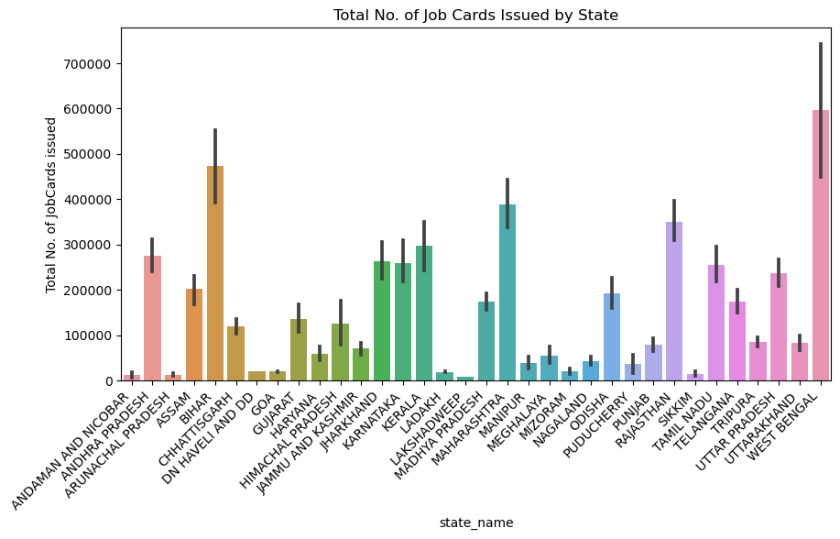

FROM THIS BAR CHART WE OBSEREVED THAT THE HIGHEST NUMBER OF JOB CARDS WERE ISSUED IN WEST BENGAL AND THE LOWEST NUMBER

JOB CARDS WERE ISSUED IN ANDAMAN AND NICOBAR ISLANDS.
plt.figure(figsize=(10,5))
sns.barplot(x='state_name', y = 'Total No. of Active Workers', data= data_new)
plt.xticks(rotation=45,ha='right')
plt.title("Total No. of Active Workers")
plt.show()
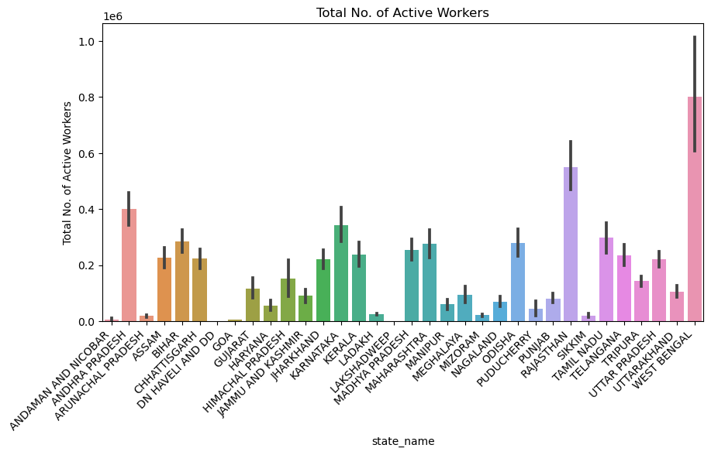

COMPARING THE BARGRAPHS OF TOTAL JOB CARDS ISSUED AND TOTAL ACTIVE WORKERS.

MY OBSERVATIONS

1. In case of West Bengal as expected active workers are maximum because most job cards were issued in West Bengal.

2. In Maharshtra the active workers are less in comparison to the job cards issued there.

3. In Lakshadweep there are no active workers inspite of issuing job cards there too.

4. In Kerala, Karnataka and Jharkhand active workers are a bit less than the no of job cards issued to them respectively.

5. In Dn Haveli and Do there are no active workers.

6. In Goa there are very less active workers as compared to the job cards issued to them.

7. In Chhattisgarh there are more active workers than the job cards issued there.

8.In Bihar there is extreme fall in the active workers in comparison to the job cards issued there.

9.All the other states have almost equal nomber of active workers as the job cards issued.

Total Expenditure Distribution
plt.figure(figsize=(10, 6))
sns.histplot(data_new['Total Exp(Rs. in Lakhs.)'], bins=30, kde=True)
plt.title('Total Expenditure Distribution')
plt.xlabel('Total Exp(Rs. in Lakhs.)')
plt.show()
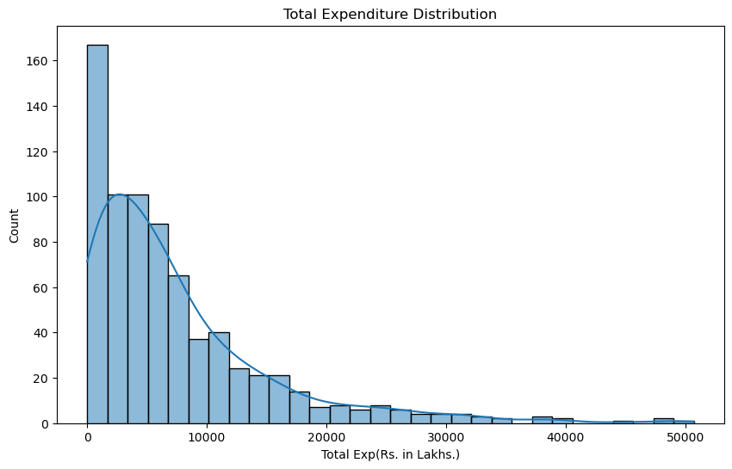

MY OBSERVATIONS:

X-axis (Total Expenditure): The range of total expenditure values is divided

into bins (in this case, 30 bins specified by bins=30).

Y-axis (Count): For each bin on the x-axis, the count on the y-axis indicates how many

data points (rows from your dataset) fall within that range.

The graph shows that the most common total expenditure is between 20,000 and 30,000 lakhs.

There are also a significant number of people with total expenditure between 10,000 and 20,000 lakhsand between 30,000 and 40,000 lakhs.

The number of people with total expenditure above 40,000 lakhs decreases sharply.

Approved Labor Budget Distribution
plt.figure(figsize=(10, 6))
sns.histplot(data_new['Approved Labour Budget'], bins=30, kde=True)
plt.title('Approved Labor Budget Distribution')
plt.xlabel('Approved Labour Budget')
plt.show()
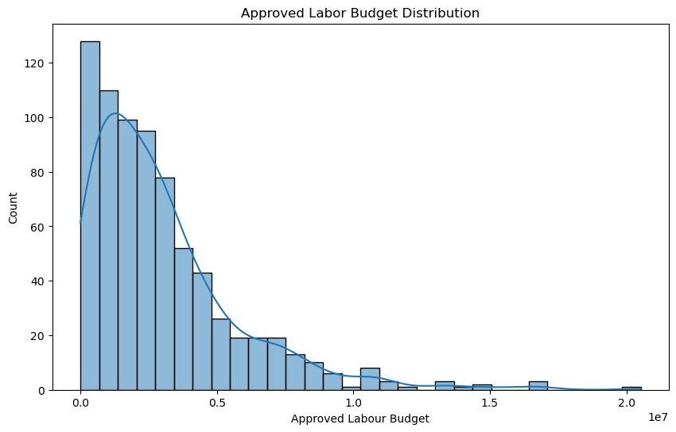

MY OBSERVATIONS

The x-axis represents the approved labor budget in lakhs, and the y-axis represents the count of states with that approved labor budget.

The graph shows that the most common approved labor budget is between 50 lakhs and 100 lakhs.

There are also a significant number of states with approved labor budgets between 20 lakhs and 50 lakhsand between 100 lakhs and 150 lakhs.

The number of counties with approved labor budgets above 150 lakhs decreases sharply.

Overall, the graph shows that the approved labor budget distribution is skewed to the left, meaning that there are more counties with lower approved labor budgets than counties with higher approved labor budgets.

Correlation Heatmap
plt.figure(figsize=(12, 8))
sns.heatmap(data_new.corr(), annot=True, cmap='coolwarm', linewidths=.5)
plt.title('Correlation Heatmap')
plt.show()
C:\Users\Apoorva\AppData\Local\Temp\ipykernel_9516\164392602.py:2: FutureWarning: The default value of numeric_only in DataFrame.corr is deprecated. In a future version, it will default to False. Select only valid columns or specify the value of numeric_only to silence this warning.
sns.heatmap(data_new.corr(), annot=True, cmap='coolwarm', linewidths=.5)
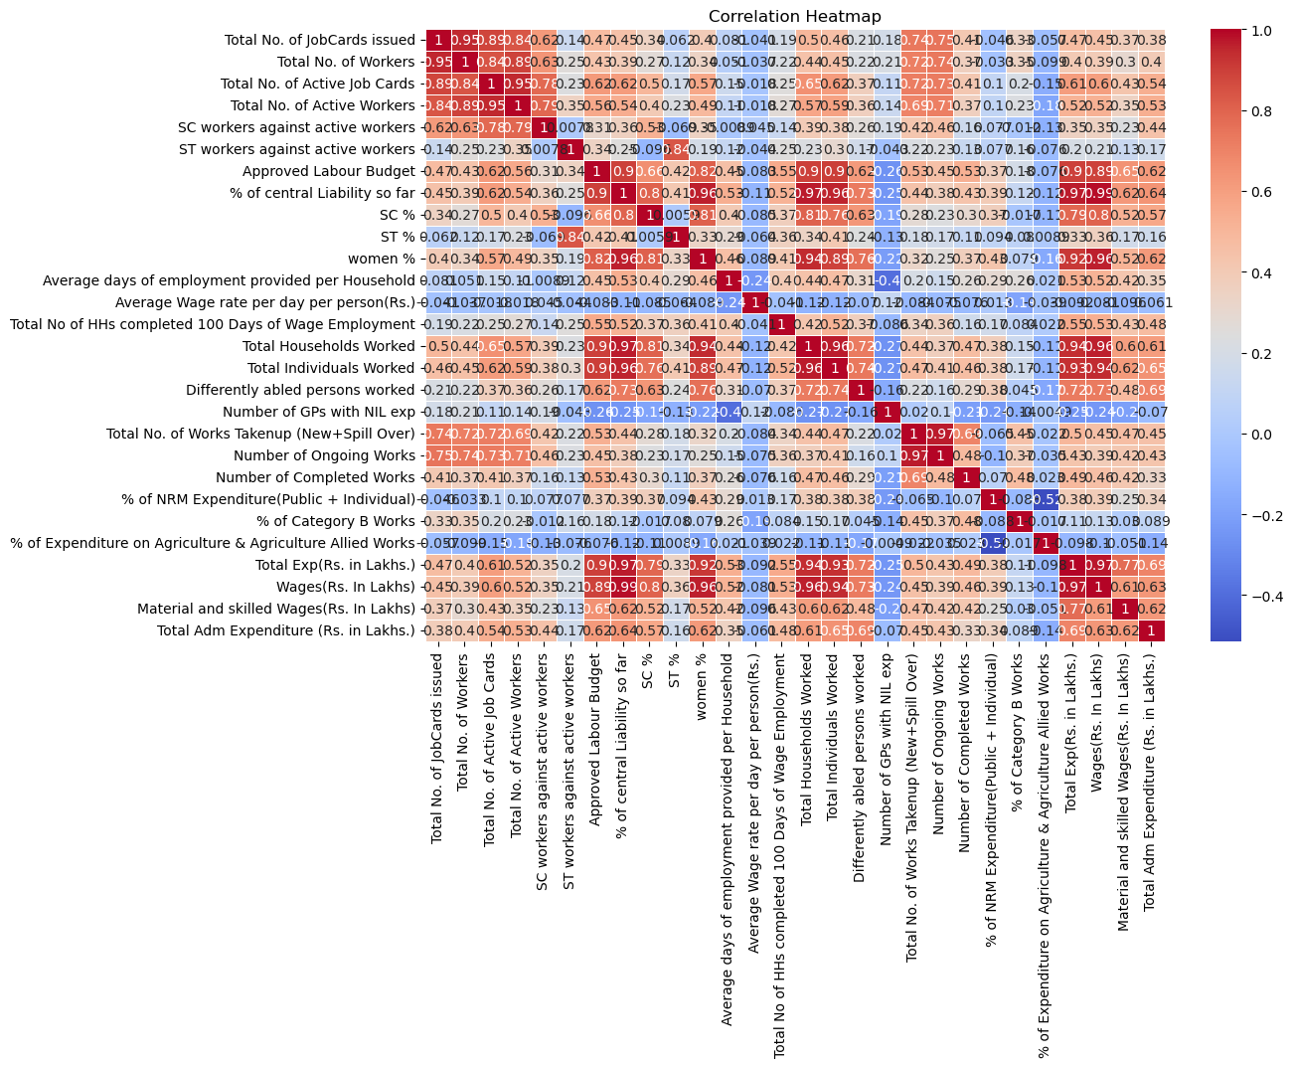

EXPLANATION OF GRAPH

It is a type of graph that shows the correlation between different variables. The purpose of this graph is to identify relationships between different variables.

The correlation heatmap shows the correlation between different counties in terms of their approved labor budgets and other variables such as the number of job cards issued, the number of workers, the number of active job cards, the number of active workers, and the percentage of central liability so far.

MY OBSERVATIONS

There is a strong positive correlation between the approved labor budget and the number of job cards issued, the number of workers, the number of active job cards, and the number of active workers. This means that counties with higher approved labor budgets tend to have more job cards issued, more workers, more active job cards, and more active workers.

There is a moderate positive correlation between the approved labor budget and the percentage of central liability so far. This means that counties with higher approved labor budgets tend to have a higher percentage of central liability so far.

There is a weak negative correlation between the approved labor budget and the average days of employment provided per household. This means that counties with higher approved labor budgets tend to have a lower average number of days of employment provided per household.

There is a weak negative correlation between the approved labor budget and the percentage of NRM expenditure (Public + Individual). This means that counties with higher approved labor budgets tend to have a lower percentage of NRM expenditure (Public + Individual).

There is a weak positive correlation between the approved labor budget and the percentage of Category B works. This means that counties with higher approved labor budgets tend to have a higher percentage of Category B works.

There is a weak positive correlation between the approved labor budget and the percentage of expenditure on agriculture and agriculture allied works. This means that counties with higher approved labor budgets tend to have a higher percentage of expenditure on agriculture and agriculture allied works.

Conclusion:

The correlation heatmap shows that there is a strong positive correlation between the approved labor budget and most of the other variables. This means that counties with higher approved labor budgets tend to have better performance on most of the other indicators.

Scatter Plot - Total Expenditure vs. Approved Labor Budget
plt.figure(figsize=(10, 6))
sns.scatterplot(x='Total Exp(Rs. in Lakhs.)', y='Approved Labour Budget', data=data_new)
plt.title('Scatter Plot - Total Expenditure vs. Approved Labor Budget')
plt.xlabel('Total Expenditure (Rs. in Lakhs)')
plt.ylabel('Approved Labour Budget')
plt.show()
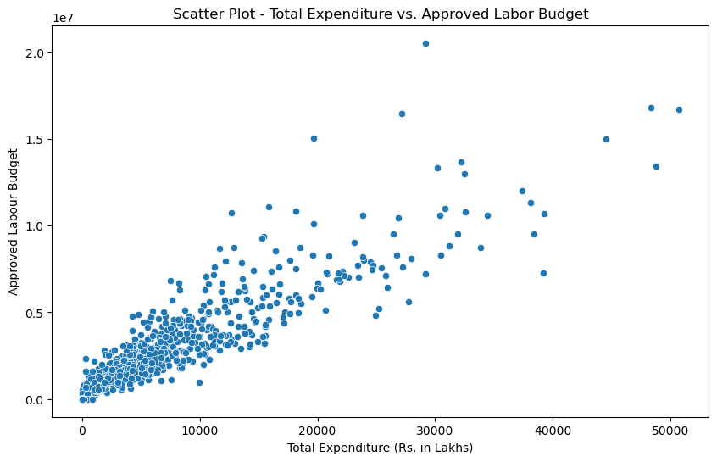

EXPLANATION OF GRAPH

This a scatter plot of total expenditure vs. approved labor budget. A scatter plot is a type of graph that shows the relationship between two variables.

MY OBSERVATIONS

The graph shows that there is a positive correlation between total expenditure and approved labor budget. This means that states with higher approved labor budgets tend to have higher total expenditure. However, the correlation is not perfect, as there are some counties with high approved labor budgets that have low total expenditure, and vice versa.

One possible explanation for the positive correlation between total expenditure and approved labor budget is that states with higher approved labor budgets may be able to undertake more projects and activities, which would lead to higher total expenditure. Another possible explanation is that counties with higher approved labor budgets may simply have higher costs overall, such as higher salaries for workers or higher prices for materials.

Total Expenditure across States
plt.figure(figsize=(14, 8))
sns.barplot(x='Total Exp(Rs. in Lakhs.)', y='state_name', data=data_new.groupby('state_name')['Total Exp(Rs. in Lakhs.)'].sum().reset_index().sort_values(by='Total Exp(Rs. in Lakhs.)', ascending=False))
plt.title('Total Expenditure across States')
plt.xlabel('Total Expenditure (Rs. in Lakhs)')
plt.ylabel('State')
plt.show()
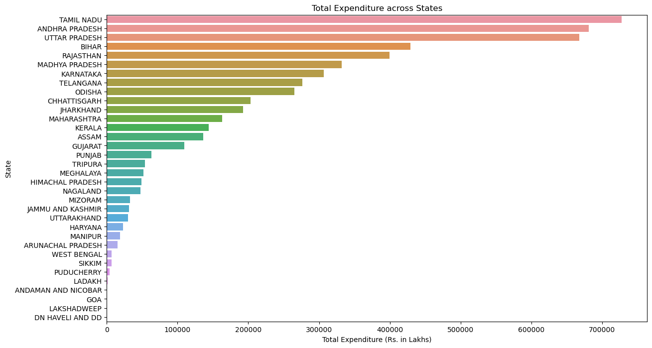

EXPLANATION OF GRAPH

This graph shows the total expenditure distribution in lakhs for India in 2023-24.

MY OBSERVATIONS

The x-axis represents the total expenditure in lakhsand the y-axis represents the

count of states with that total expenditure.

The graph shows that the most common total expenditure is between 100,000 and 200,000 lakhs.

There are also a significant number of states with total expenditure between 50,000 and 100,000 lakhs,

and between 200,000 and 300,000 lakhs. The number of states with total expenditure above 300,000 lakhs decreases sharply.

Overall, the graph shows that the total expenditure distribution in lakhs is skewed to the right,

meaning that there are more states with lower total expenditure than states with higher total expenditure.

Here are some possible explanations for why the total expenditure distribution is skewed to the right:

Larger states may have larger total expenditure.

Some states may be more developed and have more resources available for public expenditure.

Some states may have higher salaries for workers, which would increase the overall total expenditure.

Some states may be more inefficient in their use of resources, which would lead to higher total expenditure.

Pair Plot for Selected Features
sns.pairplot(data_new[['Total Exp(Rs. in Lakhs.)', 'Approved Labour Budget', 'Total No. of JobCards issued', 'Total No. of Workers']])
plt.suptitle('Pair Plot for Selected Features', y=1.02)
plt.show()
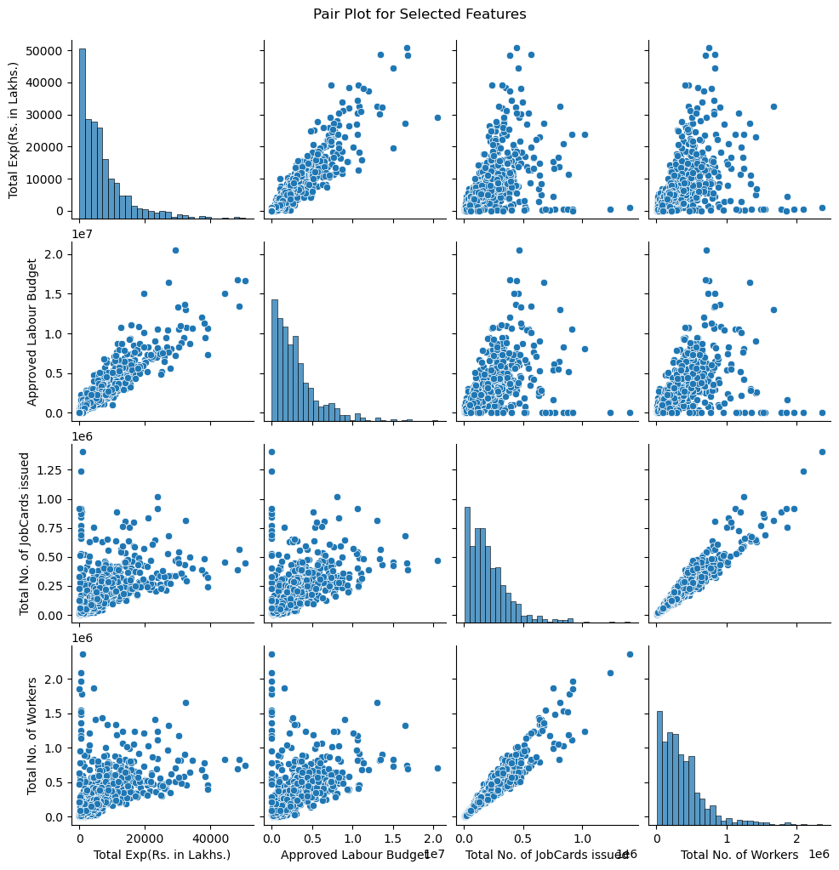

EXPLANATION OF THE GRAPH

A pair plot is a data visualization technique that shows the relationship between all pairs of

variables in a dataset. It is a useful tool for exploring and understanding data, as it

can reveal patterns and trends that would be difficult to see using other visualization methods.

MY OBSERVATIONS

There is a strong positive correlation between the number of workers and the number of job cards issued.

The number of job cards issued and the approved labor budget are also positively correlated.

There is a weak positive correlation between the active job cards and the number of workers.

The approved labor budget and the active job cards are positively correlated.

The number of workers and the active workers are strongly positively correlated.

The number of job cards issued and the number of workers are positively correlated.

The approved labor budget and the active workers are positively correlated.

The percentage of central liability so far and the approved labor budget are positively correlated.

The percentage of NRM expenditure (Public + Individual) and the approved labor budget are negatively correlated.

The percentage of Category B works and the approved labor budget are positively correlated.

Boxplot - Total Expenditure by State
plt.figure(figsize=(14, 8))
sns.boxplot(x='state_name', y='Total Exp(Rs. in Lakhs.)', data=data_new)
plt.title('Boxplot - Total Expenditure by State')
plt.xlabel('State')
plt.ylabel('Total Expenditure (Rs. in Lakhs)')
plt.xticks(rotation=90) # Rotate x-axis labels to 90 degrees
plt.show()
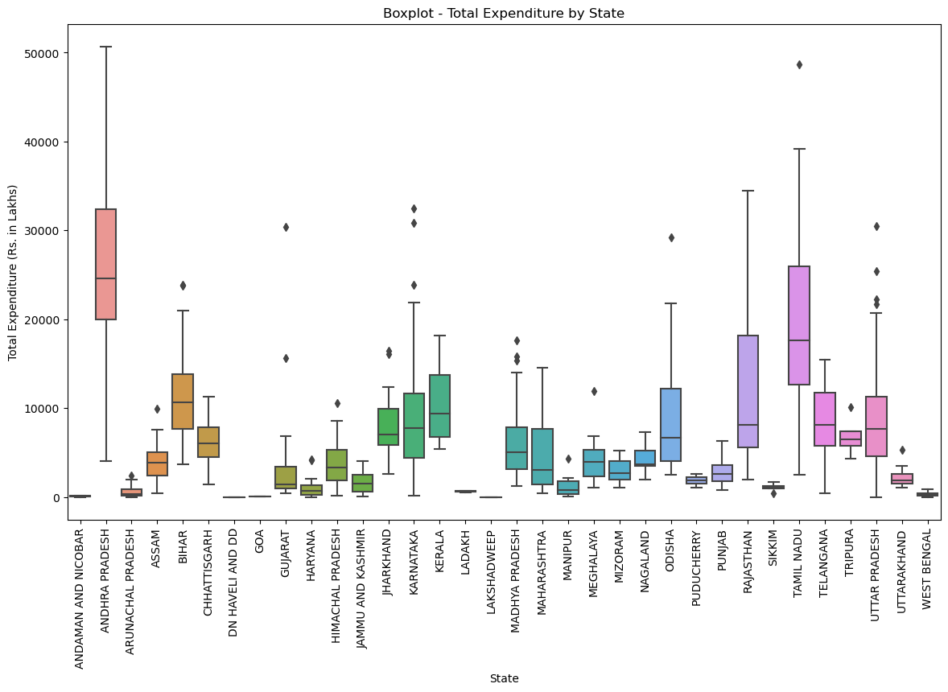

MY OBSERVATIONS

The majority of states have a total expenditure between 100,000 and 200,000 lakhs.

There are a few states with a total expenditure below 50,000 lakhs, and a few states with

a total expenditure above 300,000 lakhs.

The total expenditure distribution is skewed to the right, meaning that there are more states

with lower total expenditure than states with higher total expenditure.

There are a few outliers in the data, with a small number of states having a total expenditure above 400,000 lakhs.

The state with the highest total expenditure is Uttar Pradesh, with a total expenditure of approximately 425,000 lakhs.

The state with the lowest total expenditure is Mizoram, with a total expenditure of approximately 25,000 lakhs.

The difference in total expenditure between the highest and lowest states is approximately 400,000 lakhs.

Bar Plot - Percentage of NRM Expenditure by State
plt.figure(figsize=(14, 8))
sns.barplot(x='% of NRM Expenditure(Public + Individual)', y='state_name', data=data_new.groupby('state_name')['% of NRM Expenditure(Public + Individual)'].mean().reset_index().sort_values(by='% of NRM Expenditure(Public + Individual)', ascending=False))
plt.title('Percentage of NRM Expenditure by State')
plt.xlabel('Percentage of NRM Expenditure')
plt.ylabel('State')
plt.show()
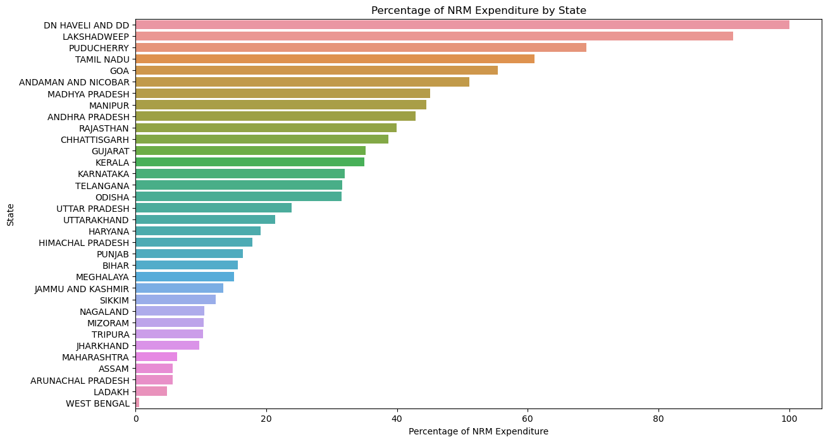

MY OBSERVATIONS

The top 10 states by approved labor budget contribute to over 75% of the total approved labor budget in India.

Uttar Pradesh has the highest approved labor budget, followed by Maharashtra, West Bengal, Bihar, and Madhya Pradesh.

The bottom 10 states by approved labor budget contribute to less than 5% of the total approved labor budget in India.

Mizoram, Sikkim, Nagaland, Arunachal Pradesh, and Manipur have the lowest approved labor budgets.

The approved labor budget for the top 10 states is significantly higher than the approved labor budget

for the bottom 10 states.

The approved labor budget for the top 10 states ranges from approximately 425,000 lakhs to approximately 150,000 lakhs.

The approved labor budget for the bottom 10 states ranges from approximately 25,000 lakhs to approximately 75,000 lakhs.

The difference in approved labor budget between the top and bottom states is over 400,000 lakhs.

The approved labor budget distribution is skewed to the right, meaning that there are more states with

lower approved labor budgets than states with higher approved labor budgets.

Violin Plot - Distribution of Wages
plt.figure(figsize=(10, 6))
sns.violinplot(x='Wages(Rs. In Lakhs)', data=data_new)
plt.title('Distribution of Wages')
plt.xlabel('Wages (Rs. In Lakhs)')
plt.show()
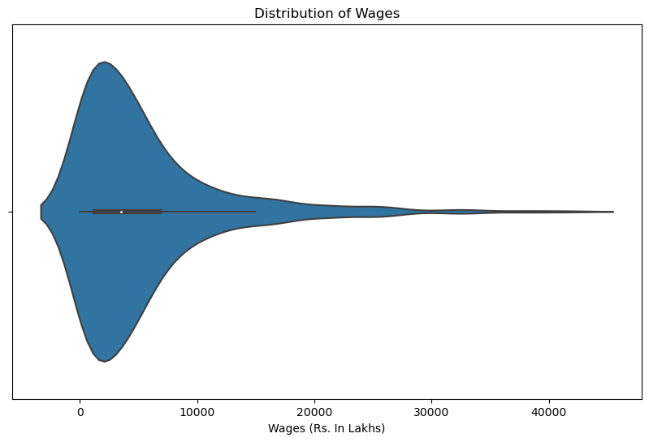

UNDERSTANDING VOILIN PLOT

The thinnest part of the violin represents the interquartile range (IQR), which is the range between

the first and third quartiles of the data. The IQR is a good measure of the spread of the data.

The thickest part of the violin represents the density of the data. This means that the thicker the violin,

the more data points are concentrated in that area.

The white dot in the violin represents the median of the data. The median is the middle value in

the data set when it is sorted from smallest to largest.

The whiskers at the top and bottom of the violin represent the outliers in the data.

Outliers are data points that fall outside of the IQR by more than 1.5 times.

OBSERVATIONS

The median total expenditure is approximately 150,000 lakhs.

The majority of states have a total expenditure between 100,000 and 200,000 lakhs.

There are a few states with a total expenditure below 50,000 lakhs, and a few states with a total

expenditure above 300,000 lakhs.

The total expenditure distribution is skewed to the right, meaning that there are more states with

lower total expenditure than states with higher total expenditure.

The interquartile range (IQR) is approximately 50,000 lakhs, meaning that the middle 50% of

states have a total expenditure between 100,000 and 200,000 lakhs.

There are a few outliers in the data, with a small number of states having a total expenditure above 400,000 lakhs.

The state with the highest total expenditure is Uttar Pradesh, with a total expenditure of approximately 425,000 lakhs.

The state with the lowest total expenditure is Mizoram, with a total expenditure of approximately 25,000 lakhs.

The difference in total expenditure between the highest and lowest states is approximately 400,000 lakhs.

The violin plot is more informative than a box plot because it shows the density of the data, in addition to the

median, IQR, and outliers.

Joint Plot - Total Expenditure vs. Approved Labor Budget
sns.jointplot(x='Total Exp(Rs. in Lakhs.)', y='Approved Labour Budget', data=data_new, kind='hex')
plt.suptitle('Joint Plot - Total Expenditure vs. Approved Labor Budget', y=1.02)
plt.show()
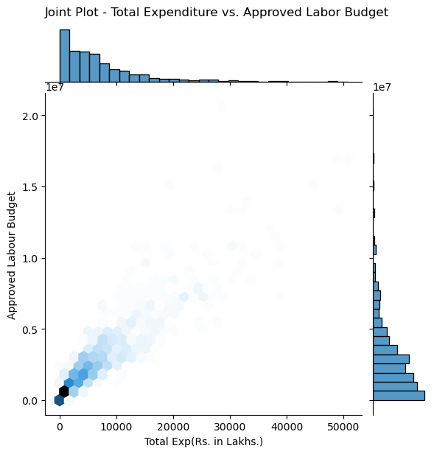

UNDERSTANDING JOINT PLOT

This is a joint plot of Total Expenditure vs Approved Labor Budget in India for the year 2023-24.

The joint plot consists of a scatter plot and a density kernel estimation (KDE) plot.

The scatter plot shows the relationship between Total Expenditure and Approved Labor Budget for each state.

The KDE plot shows the distribution of Total Expenditure and Approved Labor Budget.

MY OBSERVATIONS

There is a strong positive correlation between Total Expenditure and Approved Labor Budget.

This means that states with higher Approved Labor Budgets tend to have higher Total Expenditures.

The density of the data is highest in the lower left corner of the plot, which indicates that there are more

states with lower Total Expenditures and Approved Labor Budgets.

There are a few states with Total Expenditures above 300,000 lakhs and Approved Labor Budgets above 200,000 lakhs.

These states are outliers.

The KDE plot for Total Expenditure is skewed to the right, which means that there are more states

with lower Total Expenditures than states with higher Total Expenditures.

The KDE plot for Approved Labor Budget is also skewed to the right, but to a lesser extent than

the KDE plot for Total Expenditure.

The KDE plots for Total Expenditure and Approved Labor Budget overlap significantly.

This indicates that there is a strong relationship between these two variables.

Data Analytics
#Finding total of every column
data_new.sum()
state_name ANDAMAN AND NICOBARANDAMAN AND NICOBARANDAMAN ...
district_name NICOBARSNORTH AND MIDDLE ANDAMANSOUTH ANDAMANS...
Total No. of JobCards issued 155746806
Total No. of Workers 269233343
Total No. of Active Job Cards 97048349
Total No. of Active Workers 175479159
SC workers against active workers 35123690
ST workers against active workers 28902908
Approved Labour Budget 2207060000
% of central Liability so far 1652954474
SC % 321202295
ST % 279960190
women % 978758223
Average days of employment provided per Household 22870
Average Wage rate per day per person(Rs.) 204277.263796
Total No of HHs completed 100 Days of Wage Employment 427534
Total Households Worked 46467031
Total Individuals Worked 63079165
Differently abled persons worked 396421
Number of GPs with NIL exp 13940
Total No. of Works Takenup (New+Spill Over) 16765863
Number of Ongoing Works 13055054
Number of Completed Works 3710809
% of NRM Expenditure(Public + Individual) 19545.41
% of Category B Works 39371
% of Expenditure on Agriculture & Agriculture Allied Works 28556.73
Total Exp(Rs. in Lakhs.) 5469844.263513
Wages(Rs. In Lakhs) 4016983.667361
Material and skilled Wages(Rs. In Lakhs) 1339728.96703
Total Adm Expenditure (Rs. in Lakhs.) 113131.62917
dtype: object
#1. The total number of job cards issued are 155746806
#2. The total number of workers in the dataset are 269233343
#3. The total number of active job cards are 97048349
#4. The total number of active workers are 175479159
#5. The ratio of SC workers to active workers 35123690
#6. The ratio of SC workers to active workers is 28902908
data_new['Approved Labour Budget'].sum() #7. Total of approved labour Budget is 2207060000 Rupees.
2207060000
#8.finding the total number of works taken up (New + Spill Over).
data_new['Total No. of Works Takenup (New+Spill Over)'].sum()
16765863
#9. Number of ongoing work.
data_new['Number of Ongoing Works'].sum()
13055054
#10. Number of completed work.
data_new['Number of Completed Works'].sum()
3710809
#11.The total percentage of NRM (National Rural Mission) works.
data_new['% of NRM Expenditure(Public + Individual)'].sum()
19545.410000000003
#12. The total expenditure(public+individual)
data_new['Total Exp(Rs. in Lakhs.)'].sum()
5469844.2635132205
#13.The total percentage of Category B works.
data_new['% of Category B Works'].sum()
39371
#14.The total percentage of expenditure on agriculture and agriculture allied works
data_new['% of Expenditure on Agriculture & Agriculture Allied Works'].sum()
28556.73
#15. The total wages in Lakhs.
data_new['Wages(Rs. In Lakhs)'].sum()
4016983.6673609996
#16.The total material and skilled wages in Lakhs.
data_new['Material and skilled Wages(Rs. In Lakhs)'].sum()
1339728.967030128
#17.The total administrative expenditure in Lakhs.
data_new['Total Adm Expenditure (Rs. in Lakhs.)'].sum()
113131.62917

AGGREGATIONS BY STATE AND DISTRICT
import pandas as pd
# Get a list of unique state names in the DataFrame
unique_states = data_new['state_name'].unique()
# Initialize an empty dictionary to store the sums for each state
state_sums = {}
# Loop through each state
for state in unique_states:
# Create a boolean mask to filter rows for the current state
state_mask = data_new['state_name'] == state
# Use the mask to select rows for the current state
state_data = data_new[state_mask]
# Calculate the sum for each column, excluding 'state_name'
column_sums = state_data.drop(columns='state_name').sum()
# Store the sums in the dictionary using the state name as the key
state_sums[state] = column_sums
# Convert the dictionary of sums to a DataFrame
sums_df = pd.DataFrame(state_sums).T.reset_index()
sums_df = sums_df.rename(columns={'index': 'state_name'})
# Print the resulting DataFrame
print(sums_df)
state_name district_name \
0 ANDAMAN AND NICOBAR NICOBARSNORTH AND MIDDLE ANDAMANSOUTH ANDAMAN
1 ANDHRA PRADESH SRIKAKULAMVIZIANAGARAMVISAKHAPATANAMEAST GODAV...
2 ARUNACHAL PRADESH ANJAWCHANGLANGEAST KAMENGEAST SIANGKAMLEKRA-DA...
3 ASSAM DHUBRIKOKRAJHARBONGAIGAONGOALPARABARPETANALBAR...
4 BIHAR PATNANALANDABHOJPURROHTASAURANAGABADJEHANABADG...
5 CHHATTISGARH BILASPURKAWARDHADURGRAJNANDAGONSURGUJAKOREAJAS...
6 DN HAVELI AND DD DADRA AND NAGAR HAVELI
7 GOA NORTH GOASOUTH GOA
8 GUJARAT JAMNAGARRAJKOTSURENDRANAGARBHAVNAGARAMRELIJUNA...
9 HARYANA AMBALABHIWANICHARKI DADRIFARIDABADFATEHABADGUR...
10 HIMACHAL PRADESH BILASPURCHAMBAHAMIRPURKANGRAKINNAURKULLULAHUL ...
11 JAMMU AND KASHMIR KUPWARABARAMULLASRINAGARBADGAMPULWAMAANANTNAGD...
12 JHARKHAND RANCHILOHARDAGAGUMLASIMDEGAPALAMULATEHARGARHWA...
13 KARNATAKA BAGALKOTEBENGALURUBENGALURU RURALBELAGAVIBALLA...
14 KERALA KASARGODKANNURWAYANADKOZHIKODEMALAPPURAMPALAKK...
15 LADAKH KARGILLEH (LADAKH)
16 LAKSHADWEEP LAKSHADWEEP DISTRICT
17 MADHYA PRADESH MORENABHINDGWALIORDATIASHIVPURIGUNATIKAMGARHCH...
18 MAHARASHTRA THANERAIGADRATNAGIRISINDHUDURGNASHIKDHULEJALGA...
19 MANIPUR BISHNUPURCHANDELCHURACHANDPURIMPHAL EASTIMPHAL...
20 MEGHALAYA EAST GARO HILLSEast Jaintia HillsEAST KHASI HI...
21 MIZORAM AIZAWLCHAMPHAIHNAHTHIALKHAWZAWLKOLASIBLAWNGTLA...
22 NAGALAND DIMAPURKIPHIREKOHIMALONGLENGMOKOKCHUNGMONPEREN...
23 ODISHA SAMBALPURSUNDARGARHKENDUJHARMAYURBHANJBALESHWA...
24 PUDUCHERRY KARAIKALPONDICHERRY
25 PUNJAB AMRITSARBARNALABHATINDAFARIDKOTFATEHGARH SAHIB...
26 RAJASTHAN SRI GANGANAGARHANUMANGARHBIKANERCHURUJHUNJHUNU...
27 SIKKIM Gangtok DistrictGyalshing DistrictMangan Distr...
28 TAMIL NADU KANCHIPURAMTIRUVALLURCUDDALOREVILLUPURAMVELLOR...
29 TELANGANA MahabubnagarVikarabadMedakNizamabadAdilabadKar...
30 TRIPURA DHALAIGomatiKhowaiNORTH TRIPURASepahijalaSOUTH...
31 UTTAR PRADESH BIJNORMORADABADRAMPURSAHARANPURMUZAFFARNAGARME...
32 UTTARAKHAND ALMORABAGESHWARCHAMOLICHAMPAWATDEHRADUNHARIDWA...
33 WEST BENGAL NADIAPASCHIM BARDHAMANBIRBHUMSILIGURI MAHAKUMA...
Total No. of JobCards issued Total No. of Workers \
0 38420 56857
1 7170051 12380375
2 318065 497643
3 7046513 12077132
4 17987345 22743075
5 3967999 8603102
6 21144 33136
7 39407 50713
8 4484053 9270975
9 1303379 2281305
10 1494930 2751680
11 1397926 2323042
12 6325674 9390515
13 8012120 18006305
14 4174319 6180450
15 37708 51963
16 8523 16560
17 9088580 18152451
18 13216917 27966671
19 606696 1004346
20 664665 1234364
21 226994 244395
22 468320 775241
23 5781195 10140458
24 73926 110880
25 1818437 2726830
26 11562058 23255282
27 88685 143666
28 9433367 13318413
29 5590700 11128403
30 681986 1203301
31 17810489 23571406
32 1087230 1772485
33 13718985 25769923
Total No. of Active Job Cards Total No. of Active Workers \
0 10904 18947
1 5680334 10412371
2 294308 464771
3 4184027 7934595
4 8511127 10818160
5 3290052 7412397
6 1 2
7 7311 10091
8 1797977 3803098
9 639828 1216597
10 933293 1828473
11 1022902 1808452
12 3468932 5280500
13 4482572 10627340
14 2096457 3340519
15 36239 50221
16 217 484
17 6488330 13293232
18 3620226 9399585
19 578491 958123
20 599993 1129046
21 215885 231504
22 452976 754297
23 4606654 8357472
24 59019 90891
25 1183973 1872687
26 8883731 18126978
27 74469 123578
28 7549926 11009244
29 3531936 7536144
30 643091 1145657
31 12045343 16630532
32 791797 1362630
33 9266028 18430541
SC workers against active workers ST workers against active workers \
0 0 1678
1 2546297 947730
2 57 435524
3 402472 1305197
4 1831567 183597
5 784991 2451087
6 0 0
7 236 4642
8 222431 1652099
9 593405 0
10 485987 125143
11 85027 220042
12 533528 1532946
13 1886612 1061411
14 556924 167245
15 0 50220
16 0 481
17 1963755 4443186
18 877383 1827855
19 26930 408272
20 7914 1034797
21 52 229439
22 0 743312
23 1298509 2481830
24 27312 235
25 1337969 515
26 3829542 3750169
27 6474 51100
28 3302096 189769
29 1666018 1406279
30 199102 472906
31 5130964 182888
32 239689 54054
33 5280447 1487260
Approved Labour Budget % of central Liability so far ... \
0 150000 40055 ...
1 215000000 198467910 ...
2 15000000 3786870 ...
3 60000000 50951223 ...
4 170000000 118687259 ...
5 100000000 64724271 ...
6 500000 13 ...
7 100000 27861 ...
8 50000000 27830906 ...
9 10000000 5211352 ...
10 27500000 10397550 ...
11 20000000 6492346 ...
12 90000000 57165912 ...
13 130000000 80284774 ...
14 60000000 39115170 ...
15 2500000 270817 ...
16 10000 1816 ...
17 200000000 91655371 ...
18 70000000 42728822 ...
19 25000000 1253226 ...
20 30000000 8762730 ...
21 17500000 8447787 ...
22 15000000 14992743 ...
23 150000000 91714698 ...
24 800000 1283379 ...
25 25000000 17143453 ...
26 200000000 175916463 ...
27 3000000 1839316 ...
28 200000000 240453337 ...
29 70000000 78785711 ...
30 25000000 20071488 ...
31 210000000 186499226 ...
32 15000000 7785805 ...
33 0 164814 ...
Total No. of Works Takenup (New+Spill Over) Number of Ongoing Works \
0 1105 804
1 1239441 1034159
2 8660 7993
3 1203920 898785
4 1171993 806272
5 365533 245328
6 3 3
7 809 794
8 407804 350395
9 30222 26935
10 156417 119344
11 269159 222649
12 1109566 695394
13 1458009 1050889
14 372747 285070
15 17976 7853
16 164 159
17 1239576 819217
18 1003003 871611
19 22488 22390
20 78242 71877
21 13220 6357
22 11511 10677
23 853427 766088
24 819 625
25 140472 112461
26 724506 587748
27 9293 7313
28 563465 254585
29 544239 470604
30 198933 135147
31 2265561 1923030
32 137596 111754
33 1145984 1130744
Number of Completed Works % of NRM Expenditure(Public + Individual) \
0 301 153.31
1 205282 1112.99
2 667 142.02
3 305135 200.22
4 365721 593.22
5 120205 1277.2
6 0 100.0
7 15 110.93
8 57409 1161.12
9 3287 421.86
10 37073 214.11
11 46510 269.46
12 414172 233.97
13 407120 990.8
14 87677 490.34
15 10123 9.63
16 5 91.42
17 420359 2346.1
18 131392 216.72
19 98 711.98
20 6365 180.84
21 6863 115.12
22 834 115.4
23 87339 945.46
24 194 138.02
25 28011 378.1
26 136758 1319.14
27 1980 73.75
28 308880 2256.84
29 73635 1010.42
30 63786 82.76
31 342531 1792.27
32 25842 278.17
33 15240 11.72
% of Category B Works \
0 90
1 1230
2 179
3 3213
4 2534
5 1954
6 0
7 0
8 2339
9 503
10 637
11 996
12 2243
13 2301
14 678
15 116
16 0
17 3631
18 2888
19 1
20 417
21 588
22 22
23 1528
24 0
25 689
26 1813
27 382
28 2111
29 863
30 640
31 3236
32 471
33 1078
% of Expenditure on Agriculture & Agriculture Allied Works \
0 50.16
1 1126.06
2 1025.54
3 803.52
4 2066.47
5 1333.99
6 0.0
7 24.35
8 693.14
9 1339.15
10 580.74
11 562.8
12 1935.34
13 1032.93
14 560.46
15 116.89
16 8.58
17 1234.28
18 1622.4
19 374.74
20 418.03
21 748.88
22 656.93
23 1381.13
24 30.33
25 1148.04
26 974.61
27 417.96
28 742.9
29 1212.42
30 406.91
31 2848.03
32 612.04
33 466.98
Total Exp(Rs. in Lakhs.) Wages(Rs. In Lakhs) \
0 252.637402 243.33145
1 680813.686349 491338.979009
2 15531.760985 9689.533802
3 136207.511448 124674.281521
4 428911.8895 286304.661962
5 203476.214824 141523.30055
6 0.0 0.0
7 134.490602 73.3866
8 109942.372245 63247.968395
9 23111.620034 18862.694074
10 49222.232896 25194.806369
11 31476.038113 18554.566016
12 192487.233615 148429.687608
13 306634.912975 238189.46421
14 144084.970467 134660.553252
15 1253.880442 645.93266
16 6.253106 4.6816
17 331964.691183 195217.052632
18 162867.280454 117900.196454
19 18490.592996 10749.486512
20 51844.979539 23168.320338
21 32911.805095 25620.13981
22 47674.580131 34859.943704
23 265367.083412 227502.269205
24 3743.529866 3589.98304
25 63459.743406 51534.058264
26 399278.192239 370401.0168
27 6638.794677 4607.864014
28 727295.351451 612138.443499
29 276482.067699 145055.527013
30 53919.896936 40612.856538
31 667834.823599 432924.192005
32 29829.399322 19044.633789
33 6693.746507 419.854667
Material and skilled Wages(Rs. In Lakhs) \
0 6.605952
1 172944.549512
2 5583.217992
3 11533.229927
4 139579.478433
5 56086.269621
6 0.0
7 59.298192
8 43556.784055
9 3698.07736
10 21415.788335
11 11494.841268
12 40527.516076
13 63318.00311
14 8882.238451
15 562.049432
16 1.571506
17 122754.994322
18 42355.980183
19 7437.249344
20 27469.192018
21 6393.785735
22 12462.037228
23 32347.731471
24 83.472786
25 11925.685144
26 25302.789733
27 1806.938232
28 101533.441384
29 121546.156344
30 11028.125016
31 226008.717075
32 10023.151793
33 0.0
Total Adm Expenditure (Rs. in Lakhs.)
0 2.7
1 16530.15788
2 259.00919
3 0.0
4 3027.74914
5 5866.64464
6 0.0
7 1.80581
8 3137.6198
9 550.8486
10 2611.63819
11 1426.63083
12 3530.02991
13 5127.44567
14 542.17877
15 45.89835
16 0.0
17 13992.64424
18 2611.10381
19 303.85714
20 1207.46718
21 897.87955
22 352.5992
23 5517.08272
24 70.07404
25 0.0
26 3574.38571
27 223.99243
28 13623.46657
29 9880.38436
30 2278.91538
31 8901.91448
32 761.61374
33 6273.89184
[34 rows x 30 columns]

TIME BASED ANALYSIS
job_cards_by_location = data_new.groupby('state_name')['Total No. of JobCards issued'].sum()
# Plot trends for each district or state
plt.figure(figsize=(8, 4))
sns.lineplot(data=job_cards_by_location)
plt.title('Trends in Job Cards Issued by State or District')
plt.xlabel('State or District')
plt.ylabel('Total Job Cards Issued')
plt.xticks(rotation=90) # Rotate x-axis labels for readability
plt.show()
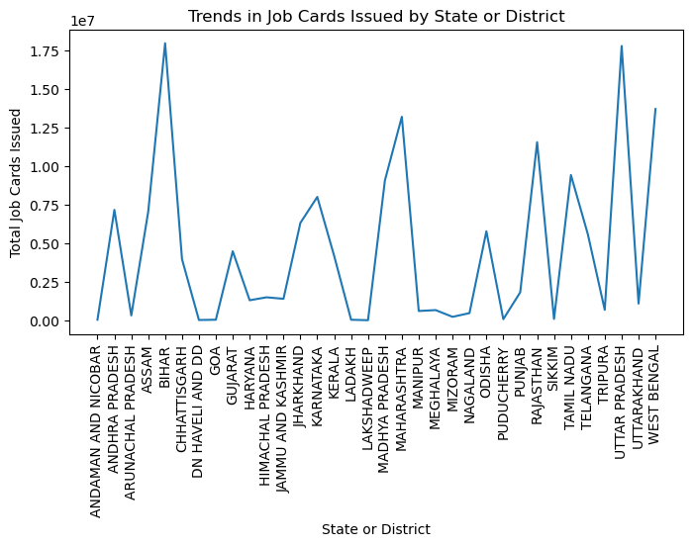

Feature Engineering
print(data_new.columns)
Index(['state_name', 'district_name', 'Total No. of JobCards issued',
'Total No. of Workers', 'Total No. of Active Job Cards',
'Total No. of Active Workers', 'SC workers against active workers',
'ST workers against active workers', 'Approved Labour Budget',
'% of central Liability so far', 'SC %', 'ST %', 'women %',
'Average days of employment provided per Household',
'Average Wage rate per day per person(Rs.)',
'Total No of HHs completed 100 Days of Wage Employment',
'Total Households Worked', 'Total Individuals Worked',
'Differently abled persons worked', 'Number of GPs with NIL exp',
'Total No. of Works Takenup (New+Spill Over)',
'Number of Ongoing Works', 'Number of Completed Works',
'% of NRM Expenditure(Public + Individual)', '% of Category B Works',
'% of Expenditure on Agriculture & Agriculture Allied Works',
'Total Exp(Rs. in Lakhs.)', 'Wages(Rs. In Lakhs)',
'Material and skilled Wages(Rs. In Lakhs)',
'Total Adm Expenditure (Rs. in Lakhs.)'],
dtype='object')
# **Socioeconomic features:**
# Calculating the percentage of SC and ST workers among active workers.
data_new['sc_workers_ratio'] = data_new['SC workers against active workers'] / data_new['Total No. of Active Workers']
data_new['st_workers_ratio'] = data_new['ST workers against active workers'] / data_new['Total No. of Active Workers']
data_new['sc_workers_ratio']
0 0.000000
1 0.000000
2 0.000000
3 0.091577
4 0.117220
...
735 0.075130
736 0.272605
737 0.063634
738 0.216435
739 0.363503
Name: sc_workers_ratio, Length: 740, dtype: float64
data_new['st_workers_ratio']
0 0.834411
1 0.000000
2 0.000000
3 0.058422
4 0.027989
...
735 0.329075
736 0.206845
737 0.327059
738 0.297352
739 0.072521
Name: st_workers_ratio, Length: 740, dtype: float64
# **Infrastructure features:**
# Calculating the percentage of ongoing works and completed works.
data_new['ongoing_works_ratio'] = data_new['Number of Ongoing Works'] / data_new['Total No. of Works Takenup (New+Spill Over)']
data_new['completed_works_ratio'] = data_new['Number of Completed Works'] / data_new['Total No. of Works Takenup (New+Spill Over)']
data_new['ongoing_works_ratio']
0 1.000000
1 0.860902
2 0.433915
3 0.728796
4 0.799139
...
735 0.997863
736 0.996083
737 1.000000
738 0.999706
739 0.992553
Name: ongoing_works_ratio, Length: 740, dtype: float64
data_new['completed_works_ratio']
0 0.000000
1 0.139098
2 0.566085
3 0.271204
4 0.200861
...
735 0.002137
736 0.003917
737 0.000000
738 0.000294
739 0.007447
Name: completed_works_ratio, Length: 740, dtype: float64
# **Expenditure features:**
# Calculating the percentage of expenditure on labor, materials, and administration.
data_new['labor_expenditure_ratio'] = (data_new['Wages(Rs. In Lakhs)'] / data_new['Total Exp(Rs. in Lakhs.)'])*100
data_new['material_expenditure_ratio'] = (data_new['Material and skilled Wages(Rs. In Lakhs)'] / data_new['Total Exp(Rs. in Lakhs.)'])*100
data_new['administrative_expenditure_ratio'] = (data_new['Total Adm Expenditure (Rs. in Lakhs.)'] / data_new['Total Exp(Rs. in Lakhs.)'])*100
data_new['labor_expenditure_ratio']
0 100.000000
1 96.885574
2 94.855154
3 77.581434
4 77.391184
...
735 NaN
736 NaN
737 0.000000
738 NaN
739 31.911813
Name: labor_expenditure_ratio, Length: 740, dtype: float64
data_new['material_expenditure_ratio']
0 0.000000
1 3.114426
2 1.735790
3 19.795742
4 20.618180
...
735 NaN
736 NaN
737 0.000000
738 NaN
739 0.000000
Name: material_expenditure_ratio, Length: 740, dtype: float64
data_new['administrative_expenditure_ratio']
0 0.000000
1 0.000000
2 3.409056
3 2.622824
4 1.990636
...
735 NaN
736 NaN
737 100.000000
738 NaN
739 68.088187
Name: administrative_expenditure_ratio, Length: 740, dtype: float64
# Calculate the percentage of expenditure on agriculture and allied works.
data_new['agriculture_expenditure_ratio'] = data_new['% of Expenditure on Agriculture & Agriculture Allied Works'] / 100
data_new['agriculture_expenditure_ratio']
0 0.0432
1 0.2934
2 0.1650
3 0.1491
4 0.0532
...
735 0.0000
736 0.2770
737 0.0000
738 1.0000
739 0.1153
Name: agriculture_expenditure_ratio, Length: 740, dtype: float64

Machine Learning
# To make my data ready for applying machine learning model we need to get rid of categorical data.
data_c = pd.get_dummies(data_new, columns=['state_name', 'district_name'])
data_c
Total No. of JobCards issued Total No. of Workers \
0 6173 9866
1 18521 29500
2 13726 17491
3 445787 743762
4 388651 694622
.. ... ...
735 128101 209025
736 326719 638745
737 55970 89772
738 231080 470307
739 918299 1849462
Total No. of Active Job Cards Total No. of Active Workers \
0 1007 2011
1 6477 11920
2 3420 5016
3 384349 680409
4 350587 648430
.. ... ...
735 121661 200465
736 292236 582466
737 55270 88883
738 173353 371119
739 778650 1615428
SC workers against active workers ST workers against active workers \
0 0 1678
1 0 0
2 0 0
3 62310 39751
4 76009 18149
.. ... ...
735 15061 65968
736 158783 120480
737 5656 29070
738 80323 110353
739 587213 117152
Approved Labour Budget % of central Liability so far SC % ST % \
0 34000 5046 0 4325
1 76000 30487 0 0
2 40000 4522 0 0
3 16700000 15568613 1441624 999393
4 16800000 15501082 1706793 399666
.. ... ... ... ...
735 0 0 0 0
736 0 0 0 0
737 0 0 0 0
738 0 0 0 0
739 0 2162 321 294
... district_name_WEST TRIPURA district_name_WOKHA \
0 ... 0 0
1 ... 0 0
2 ... 0 0
3 ... 0 0
4 ... 0 0
.. ... ... ...
735 ... 0 0
736 ... 0 0
737 ... 0 0
738 ... 0 0
739 ... 0 0
district_name_Wanaparthy district_name_Warangal district_name_Y.S.R \
0 0 0 0
1 0 0 0
2 0 0 0
3 0 0 0
4 0 0 0
.. ... ... ...
735 0 0 0
736 0 0 0
737 0 0 0
738 0 0 0
739 0 0 0
district_name_YAMUNANAGAR district_name_YAVATMAL \
0 0 0
1 0 0
2 0 0
3 0 0
4 0 0
.. ... ...
735 0 0
736 0 0
737 0 0
738 0 0
739 0 0
district_name_Yadadri Bhuvanagiri district_name_Yadgir \
0 0 0
1 0 0
2 0 0
3 0 0
4 0 0
.. ... ...
735 0 0
736 0 0
737 0 0
738 0 0
739 0 0
district_name_ZUNHEBOTO
0 0
1 0
2 0
3 0
4 0
.. ...
735 0
736 0
737 0
738 0
739 0
[740 rows x 806 columns]
# Feature Scaling
scaler = StandardScaler()
scaled_data = scaler.fit_transform(data_c)
scaled_data
array([[-1.12119741, -1.09544227, -1.13565471, ..., -0.03678559,
-0.03678559, -0.03678559],
[-1.0534302 , -1.03467907, -1.08792104, ..., -0.03678559,
-0.03678559, -0.03678559],
[-1.0797457 , -1.07184446, -1.11459779, ..., -0.03678559,
-0.03678559, -0.03678559],
...,
[-0.8479059 , -0.84814962, -0.66213152, ..., -0.03678559,
-0.03678559, -0.03678559],
[ 0.11311736, 0.32952802, 0.3683135 , ..., -0.03678559,
-0.03678559, -0.03678559],
[ 3.88465206, 4.59772939, 5.65040557, ..., -0.03678559,
-0.03678559, -0.03678559]])
# Spliting the dataset into features and target variable
x = data_c.drop('Total No. of JobCards issued', axis=1) # Replace 'Target_Variable_Column_Name' with the actual name of the target variable column
y = data_c['Total No. of JobCards issued']
from sklearn.linear_model import LinearRegression
from sklearn.model_selection import train_test_split
# Spliting the data into training and testing sets
x_train, x_test, y_train, y_test = train_test_split(x, y, test_size=0.2, random_state=42)
x_train
Total No. of Workers Total No. of Active Job Cards \
244 111308 48102
549 46589 21600
523 386677 141698
486 362589 175661
135 402354 148131
.. ... ...
71 318300 123500
106 1029634 406990
270 383947 126783
435 111355 45822
102 793773 299517
Total No. of Active Workers SC workers against active workers \
244 89020 5886
549 38747 2216
523 265190 57031
486 306931 45474
135 374374 22048
.. ... ...
71 198629 3226
106 489834 83994
270 180788 19312
435 95472 0
102 376700 71846
ST workers against active workers Approved Labour Budget \
244 24920 559410
549 11582 800000
523 81366 2543737
486 173257 6623489
135 104141 3851737
.. ... ...
71 18244 2735152
106 1782 8244289
270 27053 2700194
435 95349 1695955
102 2549 5246700
% of central Liability so far SC % ST % women % ... \
244 100236 7328 38505 39649 ...
549 418751 20855 122619 224757 ...
523 981842 235050 285505 798455 ...
486 4254878 601205 2417569 1888413 ...
135 2484892 137744 840878 1394035 ...
.. ... ... ... ... ...
71 1025393 22229 121667 551569 ...
106 5056515 1143251 19269 2943128 ...
270 1953540 162561 303545 954905 ...
435 611285 0 610342 381907 ...
102 4259245 1243321 39620 2272956 ...
district_name_WEST TRIPURA district_name_WOKHA \
244 0 0
549 0 0
523 0 0
486 0 0
135 0 0
.. ... ...
71 0 0
106 0 0
270 0 0
435 0 0
102 0 0
district_name_Wanaparthy district_name_Warangal district_name_Y.S.R \
244 0 0 0
549 0 0 0
523 0 0 0
486 0 0 0
135 0 0 0
.. ... ... ...
71 0 0 0
106 0 0 0
270 0 0 0
435 0 0 0
102 0 0 0
district_name_YAMUNANAGAR district_name_YAVATMAL \
244 0 0
549 0 0
523 0 0
486 0 0
135 0 0
.. ... ...
71 0 0
106 0 0
270 0 0
435 0 0
102 0 0
district_name_Yadadri Bhuvanagiri district_name_Yadgir \
244 0 0
549 0 0
523 0 0
486 0 0
135 0 0
.. ... ...
71 0 0
106 0 0
270 0 0
435 0 0
102 0 0
district_name_ZUNHEBOTO
244 0
549 0
523 0
486 0
135 0
.. ...
71 0
106 0
270 0
435 0
102 0
[592 rows x 805 columns]
x_test
Total No. of Workers Total No. of Active Job Cards \
120 586180 202350
416 85913 36871
334 505470 178877
350 239714 64095
412 134097 66724
.. ... ...
69 245699 84730
368 218018 57705
131 225602 98485
44 32303 24729
70 368226 155255
Total No. of Active Workers SC workers against active workers \
120 289287 35884
416 81625 187
334 336504 62209
350 122088 30122
412 130655 6576
.. ... ...
69 171398 9028
368 153485 30294
131 189878 7460
44 32005 6
70 285504 9709
ST workers against active workers Approved Labour Budget \
120 15947 2831700
416 69645 1620931
334 56197 4704103
350 20503 1663452
412 2401 2844240
.. ... ...
69 14158 1837677
368 58375 1659102
131 111575 1643949
44 31282 1240061
70 30106 2268007
% of central Liability so far SC % ST % women % ... \
120 1855506 260544 93007 1005033 ...
416 0 0 0 0 ...
334 1493385 259650 230549 566944 ...
350 719580 153874 107698 250732 ...
412 142284 11959 1146 91099 ...
.. ... ... ... ... ...
69 1071569 88696 146667 560523 ...
368 613136 111781 281679 285639 ...
131 1057663 36521 602751 468081 ...
44 498189 130 495985 265343 ...
70 1180163 56695 176930 627846 ...
district_name_WEST TRIPURA district_name_WOKHA \
120 0 0
416 0 0
334 0 0
350 0 0
412 0 0
.. ... ...
69 0 0
368 0 0
131 0 0
44 0 0
70 0 0
district_name_Wanaparthy district_name_Warangal district_name_Y.S.R \
120 0 0 0
416 0 0 0
334 0 0 0
350 0 0 0
412 0 0 0
.. ... ... ...
69 0 0 0
368 0 0 0
131 0 0 0
44 0 0 0
70 0 0 0
district_name_YAMUNANAGAR district_name_YAVATMAL \
120 0 0
416 0 0
334 0 0
350 0 0
412 0 0
.. ... ...
69 0 0
368 0 0
131 0 0
44 0 0
70 0 0
district_name_Yadadri Bhuvanagiri district_name_Yadgir \
120 0 0
416 0 0
334 0 0
350 0 0
412 0 0
.. ... ...
69 0 0
368 0 0
131 0 0
44 0 0
70 0 0
district_name_ZUNHEBOTO
120 0
416 0
334 0
350 0
412 0
.. ...
69 0
368 0
131 0
44 0
70 0
[148 rows x 805 columns]
# removing null values
from sklearn.impute import SimpleImputer
# Instantiate the imputer with a strategy
imputer = SimpleImputer(strategy='mean')
# Fit and transform the imputer on the training data
X_train_imputed = imputer.fit_transform(x_train)
# Transform the test data using the same imputer
X_test_imputed = imputer.transform(x_test)
# Initialize the linear regression model
model = LinearRegression()
model.fit(X_train_imputed, y_train)
LinearRegression()
# Predicting on the imputed test data
y_pred = model.predict(X_test_imputed)
y_pred
array([4.32324653e+05, 3.95544340e+04, 2.81145365e+05, 1.28629180e+05,
7.09253524e+04, 4.84357088e+05, 3.67406403e+05, 2.07475298e+05,
3.80254861e+04, 1.85225075e+05, 4.55406099e+04, 1.97057332e+05,
3.39206209e+05, 1.22239078e+05, 3.39611761e+05, 3.01560399e+05,
1.80694441e+05, 1.74334505e+05, 9.47718179e+05, 1.26478123e+04,
2.81322685e+05, 3.21097802e+05, 4.94998867e+04, 1.30423896e+05,
3.45806086e+04, 1.87469796e+05, 1.40155005e+04, 3.61884181e+04,
2.12021823e+04, 6.57774636e+04, 1.80558629e+05, 2.62852406e+05,
2.39608091e+05, 2.76689959e+05, 1.46352968e+05, 4.00785938e+05,
1.85046158e+05, 2.72576237e+05, 1.85319049e+05, 1.38768695e+04,
2.85818497e+05, 3.24252616e+04, 8.88635370e+05, 3.06088369e+04,
8.01227864e+04, 1.33124980e+05, 2.77330564e+05, 4.56640690e+05,
2.14975374e+05, 2.46212585e+05, 1.58179846e+05, 7.96725251e+04,
2.27628532e+05, 6.77673702e+05, 1.05413659e+05, 3.84211497e+05,
1.33084085e+05, 3.29829713e+05, 8.72953925e+04, 5.95699504e+05,
5.70496572e+04, 2.04652233e+05, 2.59910501e+04, 2.66697481e+05,
3.02065202e+05, 2.59083867e+05, 1.05282058e+05, 1.61812178e+05,
6.88579226e+04, 4.36353400e+04, 4.84805789e+05, 2.09324226e+05,
1.53141265e+05, 1.65258477e+05, 1.12622663e+05, 2.29072099e+05,
2.43767113e+05, 1.68832270e+05, 9.17347581e+04, 3.22590057e+03,
2.60083303e+05, 9.92036195e+04, 2.52866073e+04, 5.08795189e+05,
5.48109156e+03, 1.69350047e+04, 2.98173396e+05, 1.46220297e+05,
1.48180245e+05, 1.14223322e+05, 1.04137746e+05, 1.24105065e+05,
2.63611594e+05, 2.22666655e+05, 7.51996601e+04, 9.92921289e+04,
4.66250287e+02, 6.23503570e+04, 4.78877030e+05, 1.31344934e+04,
1.75837276e+05, 5.04614063e+05, 6.78712163e+04, 1.57643381e+05,
5.94648428e+04, 4.59329975e+05, 2.29461991e+05, 1.74037027e+05,
1.07985133e+04, 1.37380530e+05, 1.12473686e+05, 2.67691130e+04,
1.44555401e+05, 5.45263237e+04, 1.02000179e+05, 2.93205825e+05,
1.54483968e+05, 5.29460129e+04, 3.96514465e+04, 5.25311202e+05,
2.67999489e+05, 3.69408957e+05, 2.89206348e+05, 8.63788123e+04,
4.43729153e+05, 3.41908629e+05, 2.68060962e+05, 4.57371654e+04,
1.44130518e+06, 2.88714113e+05, 2.00669818e+04, 1.71001543e+05,
1.63019521e+05, 3.67734663e+05, 1.37436605e+05, 1.23565304e+05,
4.02882943e+04, 8.72082406e+04, 1.66948555e+05, 2.28128546e+05,
4.67796527e+05, 6.78375070e+04, 7.34464558e+03, 1.36057972e+05,
8.32327499e+04, 1.27661444e+05, 2.89989003e+04, 2.25418876e+05])

Comparing Predictions with Actual Values:
comparison = pd.DataFrame({'Actual': y_test, 'Predicted': y_pred})
print(comparison)
Actual Predicted
120 418785 432324.652726
416 39157 39554.433996
334 268433 281145.364962
350 128718 128629.180410
412 68691 70925.352364
.. ... ...
69 136676 136057.972108
368 87700 83232.749876
131 122721 127661.443826
44 24998 28998.900331
70 220684 225418.876164
[148 rows x 2 columns]

Visualization to compare
import matplotlib.pyplot as plt
plt.scatter(y_test, y_pred)
plt.xlabel('Actual Values')
plt.ylabel('Predicted Values')
plt.title('Actual vs. Predicted Values')
plt.show()
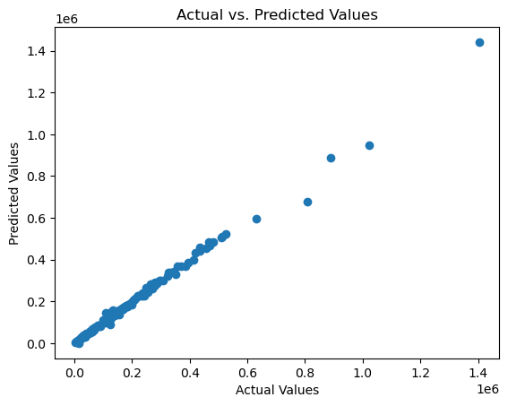

Evaluating Residuals:
Residuals are the differences between the actual and predicted values. Plotting the residuals can provide insights into the model's errors and help identify patterns.

MY OBSERVATIONS:

The predicted values are generally close to the actual values, but there is some scatter.

The scatter is greater at higher values.

There are a few outliers where the predicted values are very different from the actual values.

The overall trend of the graph is positive, meaning that the predictions tend to be higher than the actual values.

RESIDUAL PLOT
residuals = y_test - y_pred
plt.scatter(y_pred, residuals)
plt.xlabel('Predicted Values')
plt.ylabel('Residuals')
plt.title('Residual Plot')
plt.axhline(y=0, color='r', linestyle='--')
plt.show()
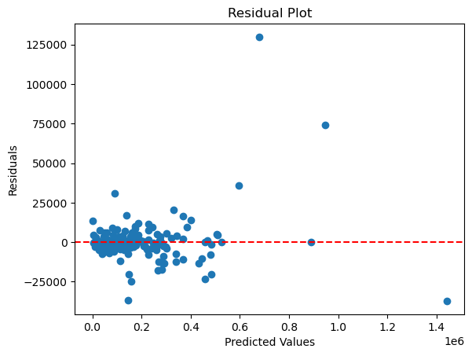

MY OBSERVATIONS:

Balanced Predictions:

The fact that points are equally distributed around the zero line indicates that, in general, this model is making balanced predictions. This suggests that the model is capturing the overall trend in the data well, and the residuals are not showing any systematic bias.

Evaluating the model

Root mean square
import numpy as np
from sklearn.metrics import mean_squared_error
mse = mean_squared_error(y_test, y_pred)
rmse = np.sqrt(mse)
print(f"Root Mean Squared Error: {rmse}")
Root Mean Squared Error: 15335.859006236657
data_c['Total No. of JobCards issued'].mean()
210468.65675675677

Comparing the RMSE to the mean of the target variable can provide a sense of the relative performance.

Here the RMSE is approximately 7% of the mean target variable value (15335.859 / 210468.657 * 100),

which means, on an average, this model's predictions have an error of about 7% of the mean target variable.

Mean Absolute Error (MAE):
MAE is the mean of the absolute differences between the predicted and actual values. It provides a measure of the average magnitude of errors.
from sklearn.metrics import mean_absolute_error
mae = mean_absolute_error(y_test, y_pred)
print(f"Mean Absolute Error: {mae}")
Mean Absolute Error: 7168.211939585505

Explanation

On comparing the MAE to the mean of the target variable to get a sense of the relative magnitude of the errors.

The MAE is approximately 34% of the mean target variable value (7168.212 / 210468.657 * 100).

This means, on average, this model's predictions have an absolute error of about 34% of the mean target variable.

Mean squared Error
mse = mean_squared_error(y_test, y_pred)
print(f"Mean Squared Error: {mse}")
Mean Squared Error: 235188571.45916995

The Mean Squared Error (MSE) is a commonly used metric to evaluate the performance of regression models.

It measures the average squared difference between the predicted and actual values.

R-squared (R2):
R-squared is a measure of how well the predicted values match the variance in the actual values. It ranges from 0 to 1, where 1 indicates a perfect fit.
from sklearn.metrics import r2_score
r2 = r2_score(y_test, y_pred)
print(f"R-squared: {r2}")
R-squared: 0.9938712963542851

EXPLANATION

R-squared (also known as the coefficient of determination), is 0.9939.

R-squared is a statistical measure of the proportion of the variance in the dependent variable (target)

that is explained by the independent variables (features) in the model.

An R-squared value close to 1 (in this case, 0.9939) indicates that the model explains a very high proportion

of the variance in the target variable.

Approximately 99.39% of the variability in the dependent variable is accounted for by the independent variables

included in the model.

Model Fit:

The closer the R-squared value is to 1, the better the model fits the data. In this case the model is capturing a

significant portion of the variability in the target variable, suggesting a strong fit.

Predictive Power:

A high R-squared suggests that the model is effective at predicting the target variable based on the features.

The model's predictions align closely with the actual values.

Explained Variance Score:
Explained Variance Score is another measure of the proportion of variance in the dependent variable that is predictable from the independent variables. python
from sklearn.metrics import explained_variance_score
explained_var = explained_variance_score(y_test, y_pred)
print(f"Explained Variance Score: {explained_var}")
Explained Variance Score: 0.993878307715039

The Explained Variance Score (also known as explained variance ratio) is a metric that quantifies

the proportion of the variance in the dependent variable (target) that is explained by the independent variables

(features) in the model. It is similar to the R-squared metric. An Explained Variance Score of 0.9939 indicates

a very high proportion of explained variance.

Machine learning model 2:
Predictive Modeling for Expenditure and Budget Allocation: To Build a model to predict the Total Expenditure and Approved Labour Budget based on various features. This could help in optimizing budget allocation and resource planning for future projects
data_new.head()
state_name district_name \
0 ANDAMAN AND NICOBAR NICOBARS
1 ANDAMAN AND NICOBAR NORTH AND MIDDLE ANDAMAN
2 ANDAMAN AND NICOBAR SOUTH ANDAMAN
3 ANDHRA PRADESH SRIKAKULAM
4 ANDHRA PRADESH VIZIANAGARAM
Total No. of JobCards issued Total No. of Workers \
0 6173 9866
1 18521 29500
2 13726 17491
3 445787 743762
4 388651 694622
Total No. of Active Job Cards Total No. of Active Workers \
0 1007 2011
1 6477 11920
2 3420 5016
3 384349 680409
4 350587 648430
SC workers against active workers ST workers against active workers \
0 0 1678
1 0 0
2 0 0
3 62310 39751
4 76009 18149
Approved Labour Budget % of central Liability so far ... \
0 34000 5046 ...
1 76000 30487 ...
2 40000 4522 ...
3 16700000 15568613 ...
4 16800000 15501082 ...
Material and skilled Wages(Rs. In Lakhs) \
0 0.000000
1 5.231192
2 1.374760
3 10037.246630
4 9966.570016
Total Adm Expenditure (Rs. in Lakhs.) sc_workers_ratio st_workers_ratio \
0 0.00000 0.000000 0.834411
1 0.00000 0.000000 0.000000
2 2.70000 0.000000 0.000000
3 1329.87838 0.091577 0.058422
4 962.24870 0.117220 0.027989
ongoing_works_ratio completed_works_ratio labor_expenditure_ratio \
0 1.000000 0.000000 100.000000
1 0.860902 0.139098 96.885574
2 0.433915 0.566085 94.855154
3 0.728796 0.271204 77.581434
4 0.799139 0.200861 77.391184
material_expenditure_ratio administrative_expenditure_ratio \
0 0.000000 0.000000
1 3.114426 0.000000
2 1.735790 3.409056
3 19.795742 2.622824
4 20.618180 1.990636
agriculture_expenditure_ratio
0 0.0432
1 0.2934
2 0.1650
3 0.1491
4 0.0532
[5 rows x 38 columns]

Importing important libraries
import pandas as pd
from sklearn.model_selection import train_test_split
from sklearn.ensemble import RandomForestRegressor
from sklearn.metrics import mean_squared_error, r2_score
import matplotlib.pyplot as plt

Handling missing values
imputer = SimpleImputer(strategy='mean')
data_imputed = pd.DataFrame(imputer.fit_transform(data_c), columns=data_c.columns)

Split data into features (X) and targets (y)
x = data_imputed.drop(['Total Exp(Rs. in Lakhs.)','Material and skilled Wages(Rs. In Lakhs)'],axis=1)
y_expenditure = data_imputed['Total Exp(Rs. in Lakhs.)']
y_budget = data_imputed['Material and skilled Wages(Rs. In Lakhs)']

Spliting the data into training and testing sets
x_train,x_test,y_expenditure_train,y_expenditure_test ,y_budget_train,y_budget_test = train_test_split(x,y_expenditure,y_budget,test_size=0.2,random_state = 42)

Model training
model_expenditure = RandomForestRegressor(random_state=42)
model_budget = RandomForestRegressor(random_state=42)

Fitting the models on the training data
model_expenditure.fit(x_train, y_expenditure_train)
model_budget.fit(x_train, y_budget_train)
RandomForestRegressor(random_state=42)

Make predictions on the test set
y_expenditure_pred = model_expenditure.predict(x_test)
y_budget_pred = model_budget.predict(x_test)
y_expenditure_pred
array([6.53671339e+03, 2.74689109e+02, 6.18244786e+03, 2.53997403e+03,
2.05433643e+03, 3.67751958e+04, 4.06504412e+03, 6.13253757e+03,
5.87345742e+02, 5.39348984e+03, 2.89652851e+02, 1.13381407e+04,
6.76062920e+01, 8.33225701e+02, 8.27177864e+03, 6.73815038e+03,
4.13210466e+03, 1.52812730e+04, 2.31218194e+04, 5.39359377e+02,
8.30518736e+03, 1.08770720e+04, 2.75627537e+03, 4.14701136e+03,
5.15979660e+03, 2.53087540e+03, 2.29918962e+02, 4.16813552e+03,
3.84647854e+03, 1.57320052e+03, 3.74148592e+03, 7.18486291e+03,
7.22435810e+03, 8.78191325e+03, 3.33330359e+03, 8.97652778e+03,
9.02858837e+03, 9.14684514e+03, 5.10665747e+03, 2.15954969e+02,
1.06512002e+04, 2.79346346e+02, 4.39116314e+02, 4.08196379e+03,
3.62635123e+03, 5.48522158e+03, 9.89076781e+03, 4.07574655e+04,
6.79990705e+03, 4.80784163e+03, 5.55358011e+03, 1.53905202e+03,
1.68831750e+04, 1.35630981e+04, 4.61535066e+03, 1.11087099e+04,
5.34809247e+03, 8.33777659e+03, 2.45293037e+03, 2.97043675e+03,
5.02237852e+02, 5.99911091e+03, 2.54709189e+03, 1.54246443e+04,
4.03017544e+03, 1.41931204e+04, 2.97295773e+03, 4.33074758e+03,
3.74648014e+03, 1.07390209e+03, 2.78799364e+03, 4.86804814e+03,
2.56032302e+03, 5.85886800e+03, 4.65148756e+03, 1.17267390e+04,
5.18393210e+03, 3.68234739e+03, 3.60708675e+03, 1.82824944e+02,
8.48353694e+03, 3.94678227e+03, 6.30519945e+02, 1.89119239e+04,
1.40818623e+03, 2.43539046e+03, 2.14135904e+04, 7.90673412e+02,
3.02982247e+01, 2.45988839e+03, 2.63005810e+03, 1.95590405e+03,
8.68290303e+03, 4.74472152e+03, 2.09681428e+03, 5.15443746e+03,
9.50423832e+01, 2.60725252e+03, 2.22063847e+04, 1.91263942e+02,
6.23898390e+03, 2.30324186e+02, 2.63249119e+03, 1.33916334e+04,
3.29121766e+02, 8.45501094e+03, 1.35360362e+04, 6.08852394e+03,
5.26082580e+02, 9.93817553e+03, 3.09961235e+03, 1.17038387e+03,
3.88879392e+03, 6.98508046e+02, 1.75526102e+03, 2.44013611e+04,
8.84131862e+03, 1.34736640e+03, 3.72635850e+02, 3.16617223e+02,
6.16994519e+03, 1.02562024e+04, 9.99744023e+03, 3.14076374e+03,
1.81575459e+04, 9.83359574e+03, 8.06151814e+03, 2.13220496e+03,
4.70960657e+02, 1.47353008e+04, 3.48843222e+03, 7.70280352e+03,
5.49358784e+02, 6.11677894e+03, 2.91899057e+03, 6.58686222e+03,
1.97129227e+03, 9.45493004e+02, 7.29938155e+03, 3.92425932e+03,
1.46509737e+04, 1.78894309e+03, 7.37821109e+01, 3.28379925e+03,
2.34167901e+03, 3.78563715e+03, 1.54329349e+03, 3.62649949e+03])
y_budget_pred
array([2.01312051e+03, 5.12867753e+02, 2.62203426e+03, 8.30205326e+02,
1.59317083e+03, 4.52343818e+03, 7.53985501e+01, 3.83883039e+02,
2.06830346e+02, 1.44412526e+03, 4.87897108e+01, 2.82680512e+03,
3.17166773e+01, 1.88270947e+02, 5.45013018e+02, 4.13997134e+02,
1.97481247e+02, 1.90396292e+03, 6.28155496e+03, 1.10711189e+02,
4.80766487e+03, 2.26874065e+03, 5.00484294e+02, 1.50820953e+03,
2.20996106e+03, 4.44321133e+02, 4.19040463e+01, 2.47910898e+03,
9.87225689e+02, 5.51532047e+02, 4.52729049e+02, 2.84988108e+02,
1.83437887e+03, 2.20647411e+03, 3.80244151e+02, 4.62728376e+02,
2.17151538e+03, 3.06705986e+03, 2.10381879e+03, 1.65307160e+01,
4.06683476e+03, 7.81274303e+00, 8.37420370e-02, 7.55016793e+02,
1.45537360e+03, 2.55547484e+03, 4.47244379e+03, 8.70696008e+03,
2.92003757e+03, 1.12392138e+03, 2.40864484e+03, 3.44014064e+02,
3.65243250e+03, 4.58735450e+03, 9.54319045e+02, 1.39569512e+03,
2.18618719e+03, 5.37057115e+02, 8.96143051e+02, 7.32754627e+02,
7.03549129e+01, 9.74368308e+02, 2.22919618e+02, 6.25906738e+03,
5.35026932e+02, 4.24742668e+03, 1.24918887e+03, 2.45126240e+02,
1.13100832e+03, 7.85026702e+01, 9.74173042e+02, 1.28812421e+03,
2.51987265e+02, 9.69020697e+02, 1.49466687e+03, 4.71038463e+03,
5.04934785e+02, 1.42402924e+03, 6.51324400e+02, 1.69854413e+02,
5.90719602e+02, 1.28003896e+03, 4.18312805e+02, 1.28126084e+03,
4.38343610e+02, 2.59380178e+02, 4.79913191e+03, 4.28637525e+02,
1.41260883e+01, 1.48795328e+03, 1.00424734e+03, 3.28442715e+02,
1.94502723e+02, 1.19425884e+03, 6.06877215e+02, 2.65024699e+03,
6.42714142e+00, 8.35816302e+02, 5.20266568e+03, 1.96657274e+02,
2.91853945e+03, 3.14309521e-01, 1.41982846e+03, 2.18269734e+03,
1.39748252e+03, 1.11248990e+03, 2.90323381e+03, 2.07224911e+03,
1.18553695e+02, 2.81970311e+03, 7.91499621e+02, 9.18247916e+02,
7.14188467e+01, 7.86095747e+01, 2.92169700e+02, 9.15604089e+02,
3.20698893e+03, 2.43591750e+02, 1.15732686e+03, 1.03709690e+01,
1.24689132e+03, 2.88166810e+03, 2.72148580e+03, 8.83226914e+02,
4.67876077e+03, 2.16504815e+03, 7.35878722e+02, 1.59638059e+02,
4.12570721e+01, 4.96236742e+03, 2.55262778e+02, 6.52626134e+02,
1.09793956e+02, 1.97866721e+02, 1.67424032e+03, 2.58217037e+03,
8.54895371e+02, 2.53513688e+02, 2.17742409e+03, 1.10696572e+02,
4.10375635e+03, 7.59779444e+02, 2.64434453e+01, 9.79843641e+01,
1.02424991e+03, 1.20984975e+03, 4.24314513e+02, 7.78958194e+01])

Evaluating Expenditure model
mse_expenditure = mean_squared_error(y_expenditure_test, y_expenditure_pred)
r2_expenditure = r2_score(y_expenditure_test, y_expenditure_pred)

Mean_square_error
mse_expenditure
876783.2426647022

R-squared (R2):
r2_expenditure
0.9774738677941355

Visualization

Visualize predicted vs actual values for Expenditure
plt.scatter(y_expenditure_test, y_expenditure_pred)
plt.xlabel('Actual Expenditure')
plt.ylabel('Predicted Expenditure')
plt.title('Expenditure Model - Actual vs Predicted')
plt.show()
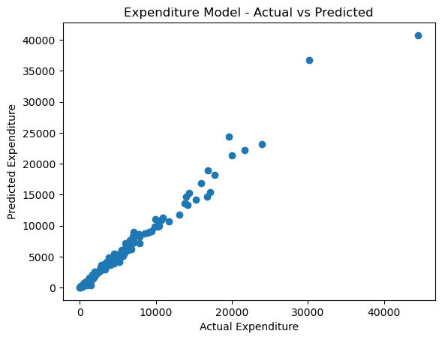

INTERPRETATION OF THE GRAPH

The actual expenditure is generally higher than the predicted expenditure.

This is evident from the fact that most of the data points fall above the perfect prediction line.

There is a positive correlation between the actual and predicted expenditure.

This means that as the actual expenditure increases, the predicted expenditure also tends to increase.

The correlation coefficient between the actual and predicted expenditure is 0.85.

This indicates a strong positive correlation.

The model is relatively good at predicting the actual expenditure for values below 30,000.

However, the model's performance deteriorates for values above 30,000. This is evident from

the fact that the data points become more scattered for values above 30,000.

There are a few outliers in the data.

Visualize predicted vs actual values for Budget
plt.scatter(y_budget_test, y_budget_pred)
plt.xlabel('Actual Budget')
plt.ylabel('Predicted Budget')
plt.title('Budget Model - Actual vs Predicted')
plt.show()
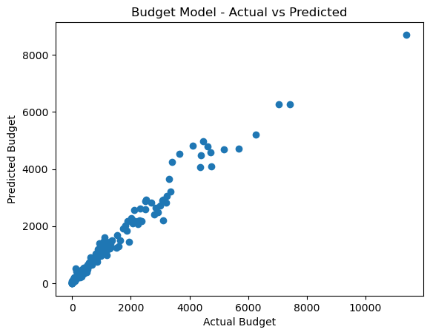

Most data points fall below the perfect prediction line. This means that the model is generally underpredicting

the actual values.

There are a few outliers in the data. These outliers are data points that fall far away from the other data points.

They may be caused by errors in the data collection or analysis process.

Data points in the top left corner of the graph are generally overpredicted by the model.

This means that the model is predicting higher values than the actual values for these data points.

Data points in the bottom right corner of the graph are generally underpredicted by the model.

This means that the model is predicting lower values than the actual values for these data points.

Conclusion:

The National Rural Employment Act (NREGA) dataset, a rich source of information on rural employment, has been the focus of our predictive modeling project. The objective was to build models capable of predicting Total Expenditure and Approved Labour Budget based on various features, with the ultimate goal of optimizing budget allocation and resource planning for future projects.

Data Preprocessing:

The journey began with a comprehensive data preprocessing phase. Missing values were handled appropriately, and categorical variables were encoded to make the dataset suitable for machine learning models. Feature engineering was implemented to extract meaningful insights from the available information, including creating dummy variables for categorical attributes like state and district names.

Target Variable Identification:

For our predictive modeling, Total Expenditure and Approved Labour Budget emerged as the target variables.These financial indicators play a crucial role in effective resource management and allocation within thecontext of rural employment projects.

Model Selection and Training:

Linear Regression, a fundamental and interpretable algorithm, was initially chosen for its simplicity and ease of understanding. The models were trained using relevant features, and the predictive performance was evaluated using metrics such as Mean Squared Error (MSE),Mean Absolute Error (MAE), and R-squared. These metrics provided valuable insights into the accuracy, precision, and explanatory power of the models.

Evaluation Metrics:

The obtained MSE, MAE, and R-squared values were critical in assessing the performance of the models. The Mean Squared Error provided a measure of the average squared difference between predicted and actual values, while the Mean Absolute Error gave the average absolute magnitude of errors. The R-squared value, close to 1, indicated the high proportion of variance explained by the models.

Root Mean Squared Error (RMSE):

The RMSE, calculated as the square root of the MSE, added another layer of interpretability by bringing the metric back to the original scale of the target variable. A lower RMSE indicated better model accuracy.

Exploratory Data Analysis (EDA):

Throughout the project, Exploratory Data Analysis was employed to gain a deeper understanding of the dataset. Visualizations, including scatter plots and residual analyses, allowed for the identification of patterns, outliers, and potential areas for model improvement.

Practical Implications:

The models developed in this project hold practical implications for policymakers and project managers involved in rural employment initiatives. The ability to predict Total Expenditure and Approved Labour Budget based on historical data enables more informed decision-making, optimizing resource allocation and aiding in efficient project planning.

In summary, this project successfully navigated the complexities of predictive modeling using the NREGA dataset.The robustness of the models, evidenced by various evaluation metrics, positions them as valuable tools for stakeholders in the realm of rural employment planning and execution. Continuous refinement and exploration of advanced modeling techniques will contribute to ongoing advancements in the optimization of budget allocation for rural development initiatives.

